Table of Contents

Section 1 Introduction 1-1

1.1 Background 1-1

1.2 Objectives 1-3

1.3 Organization 1-3

Section 2 Data and Information Reviewed 1-1

2.1 Daily Monitoring Report Data 1-1

2.2 PLC Data 1-1

2.3 Process Logs 1-3

2.4 Visy Paper Data 1-4

2.5 Sampling Program 1-5

2.5.1 Bacterial Results 1-2

2.5.2 TRC, cBOD and TSS Results 1-4

2.5.3 Chlorine Demand Testing 1-7

2.5.4 Particle Size Distribution 1-8

2.5.5 Other Process Data 1-8

Section 3 Data Evaluation Error! Bookmark not defined.-Error! Bookmark not defined.

3.1 Solids Flux **Error! Bookmark not defined.**-**Error! Bookmark not defined.**

3.2 Precipitation/Wet Weather Events 1-2

3.3 Process Control Challenges 1-4

3.4 Discharge from Visy Paper 1-6

3.6 Sodium Hypochlorite Use 1-6

3.7 Data Evaluation Approach 1-10

3.7.2 Statistical Evaluations 1-12

SVM Decision Tree 1-12

Logistic Regression 1-13

Random Forest 1-14

Regression 1-15

Section 4 Conclusions and Recommendations 4-19

4.1 Conclusions 4-19

4.1.1 LFT Heading 3 4-21

4.1.1.1 LFT Heading 4 4-21

4.2 Recommendations 4-22

List of Figures

Figure 1-1 Port Richmond WWRF Compliance with Proposed WQBEL of 0.53 mg/L during Demonstration Period 1-1

Figure 1-2 Effluent TRC Concentrations from July 2017 through January 2019 1-2

Figure 2-1 Timeframes for Detailed Data Evaluation 1-1

Figure 2-2 - Port Richmond Sampling Locations 6

Figure 2-3 – Port Richmond Bacterial Concentrations Sampling Time Series 3

Figure 2-4 Port Richmond Bacterial Concentration Distributions by Location 3

Figure 2-6 - Port Richmond cBOD, TSS, and TRC Concentrations by Location 5

Figure 2-5 - Port Richmond cBOD, TSS, and TRC Concentrations Sampling Time Series 5

Figure 2-7 – Investigation 1 Dose vs Demand 10

Figure 2-8 - Investigation 2 Dose vs Demand 10

Figure 2-9 - Particle Size Distribution by Volume for Day 8 of 12 1

Figure 2-10 - Particle Size Distribution by Volume for Day 10 of 12 2

Figure 2-11 July 2005 Particle Size Distribution Results 2

Figure 3-1 Effluent Fecal Coliform from 2015 through April 2019 1-1

Figure 3-2 Precipitation and TRC 1-2

Figure 3-3 Reported Influent and Effluent TRC Concentrations during October and December 2018 Storm Event 1-3

Figure 3-4 Comparison of Hach and Prominent Chlorine Measurements 1-5

Figure 3-5 Percentage of Port Richmond BOD Load from Visy Paper 1-6

Figure 3-6 State Point Characteristic Curve 1-7

Figure 3-7 State Point / Settling Flux Over Time 1-8

Figure 3-8 Chlorine Half-life 1-10

Figure 3-9 Model Receiver Operator Characteristic Curve Comparison 1-12

Figure 3- 10 Example Decision Tree on Subset of Port Richmond Data 1-12

Figure 3-11 Sample Logistic Regression with Disinfection Dose as only Predictor Variable 1-14

Figure 3-12 Factors Most Often Occurring When Effluent TRC Exceeded 0.52 mg/L 1-15

Figure 3-13 TRC concentrations by Binned Disinfection Dose (Bin intervals defined such that they contain an equivalent number of observations) 1-16

Figure 3-14 TRC concentrations by Binned influent BOD Loading Rate (Bin intervals defined such that they contain an equivalent number of observations) 1-17

Figure 3-15 - TRC concentrations by Binned Visy Paper Flow Rate (Bin intervals defined such that they contain an equivalent number of observations) [*]Plot is zoomed in and does not show all TRC observations 1-17

Figure 3-16 TRC concentrations by Binned Fecal Coliform 7-day Geomean (Bin intervals defined such they are the same length independent of number of observations) [*]Plot is zoomed in and does not show all TRC observations 1-18

Figure 3-17 TRC concentrations by Binned Effluent Suspended Solids (Bin intervals defined such they are the same length independent of number of observations) [*]Plot is zoomed in and does not show all TRC observations 1-18

Figure 4-1 Figure and Title Placement 4-22

List of Tables

Table 1-1 Overview of Effluent TRC Concentrations through February 2020 1-2

Table 2-1 Parameters Potentially Impacting Disinfection at Port Richmond WWRF 1-1

Table 2-2 Timeframes for Detailed Data Evaluation 1-2

Table 2-3 Detailed Data Provided by PLC Logs 1-2

Table 2-4 Disinfection Information from Process Logs 1-4

Table 2-5 Visy Paper Discharge Characteristics 1-4

Table 2-6 – Number of Samples Collected from Each Sample Location 1-7

Table 2-7 – DEP Sampling Program Notes 1-1

Table 2-8 – Summary Statistics of Port Richmond Bacterial Concentrations 1-4

Table 2-9 Summary Statistics of Port Richmond cBOD, TSS, and TRC Concentrations 1-6

Table 2-10 - Demand Investigation 1 1-10

Table 2-11 - Demand Investigation 2 1-10

Table 2-12 Additional DEP Operational Data 1-3

Table 3-1 Comparison of Hach and Prominent Chlorine Measurements 1-5

Table 3-2 Port Richmond Chlorine Deliveries 1-9

Table 3-3 Exceedance Event Proportions 1-11

Table 3-4 Data Model Accuracies 1-11

Table 3-5 Decision Tree Model Configuration 1-13

Table 3-10 – Logistic Regression Model Configuration 1-14

Table 3-6 Random Forest Model Configuration 1-14

Table 4-1 LFT Table Title 4-21

Appendices

Appendix A Insert Appendix Title Here

Appendix B Insert Appendix Title Here

Section   
Introduction

1.1 Background

New York City Department of Environmental Protection (NYCDEP) has completed field, laboratory and modeling studies to assess compliance with the total residual chlorine (TRC) receiving water quality criteria of 13 ug/L at the Port Richmond Wastewater Treatment Plant (WWTP) by implementation of a new outfall and diffuser configuration. Based on the increased dilution that would be provided by a reconfigured outfall/diffuser system and the results of the Port Richmond chlorine decay/degradation study, a new water quality based effluent limit (WQBEL) of 0.52 mg/L would be established, pending New York State Department of Environmental Conservation (NYSDEC) approval (Port Richmond Total Residual Chlorine Preliminary Design Report, 2017). It is anticipated that NYSDEC could reduce the State Pollutant Discharge Elimination System (SPDES) limit to less than 0.52 mg/L to provide a factor of safety.

The Port Richmond wastewater resource recovery facility (WRRF) had successfully complied with a TRC target of 0.53 mg/L during most of the November 2015 through November 2016 demonstration period as shown on **Figure 1-1** and during the more recent period from July 2017 through January 2019 that is shown by **Figure 1-2** (1). The data showed that the Port Richmond plant can successfully maintain a TRC effluent limit of 0.52 mg/L for sustained periods of time. The data also shows that there are periods of high effluent TRC concentrations that would result in exceedance of a new 0.52 mg/L limit. The most significant excursions above the limit (i.e., magnitude and duration of concentrations above 0.52 mg/L) occurred in December 2017 and December 2018 following significant wet weather events and resulting operational upsets.



Source: NYCDEP, please note that proposed WQBEL has been updated since this graphic was developed.

Figure 1-1 Port Richmond WWRF Compliance with Proposed WQBEL of 0.53 mg/L during Demonstration Period

(1) In 2015, NYSDEC’s proposed TRC permit limit was 0.53 mg/L. In 2017, NYSDEC reduced the proposed limit to 0.20 mg/L. In 2018, DEP proposed a new limit of 0.52 mg/L based on the increased dilution provided by a new outfall diffuser.

Figure 1-2 Effluent TRC Concentrations from July 2017 through January 2019

The most recent data available, summarized on **Table 1-1,** shows that Port Richmond continues to successfully achieve effluent TRC concentrations that are lower than 0.52 mg/L target most, but not all of the time.

Table 1-1 Overview of Effluent TRC Concentrations through February 2020

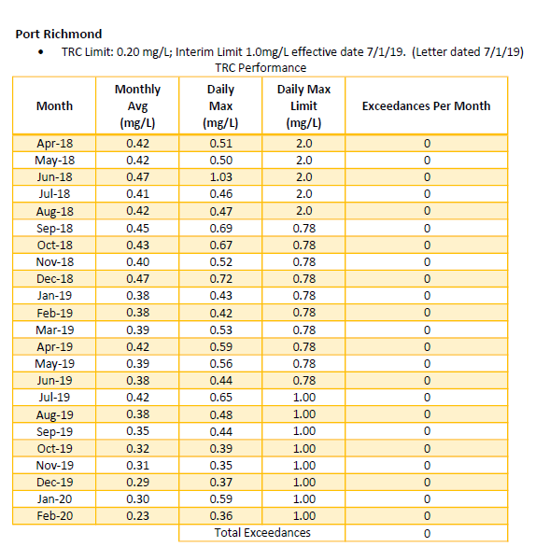

Source: NYCDEP

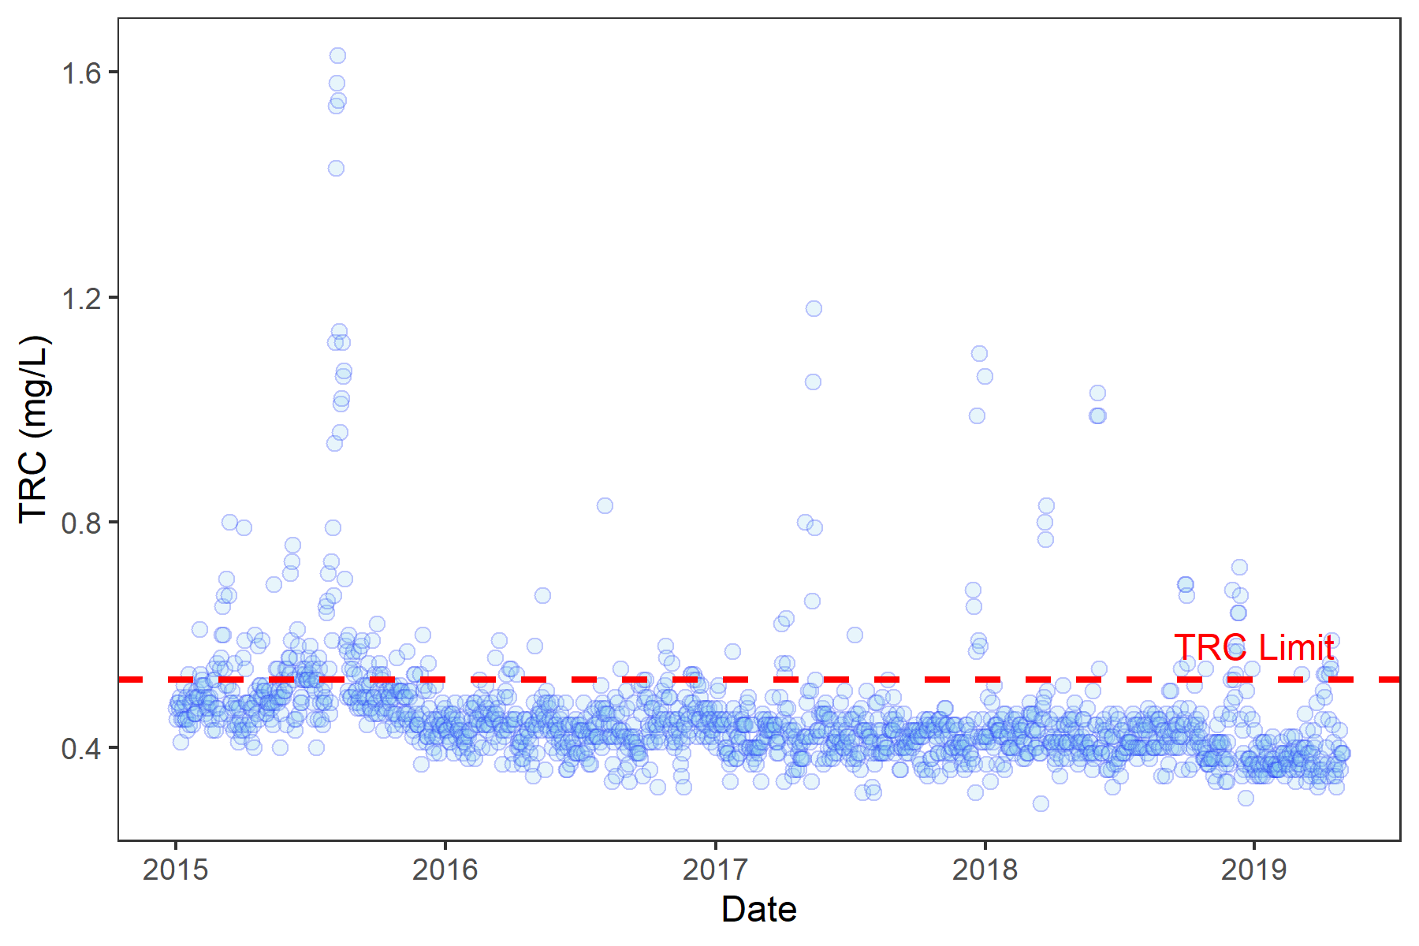Review of Port Richmond operating data indicates that there are a number of factors that contribute to inconsistent wastewater quality at the chlorine contact tanks (CCTs), prompting the disinfection challenges experienced by the plant. DEP believes the TRC excursions above the anticipated new WQBEL could potentially be resolved by understanding and improving performance of upstream plant processes.

1.2 Objectives

The objectives of this technical memorandum are to:

* Identify the factors causing inconsistent secondary effluent quality and
* Identify the infrastructure and/or operational improvements required to increase effluent consistency and support consistent achievement of an effluent TRC of less than 0.52 mg/L while maintaining compliance with permitted limits for fecal coliform.

1.3 Organization

Section 2 of this technical memorandum identifies the sources of the data that was reviewed and presents the initial data evaluations and correlations that were used to assess potential relationships between effluent total residual chlorine (TRC) and factors such as precipitation, upstream processes and other factors.

Section 3 explains the impacts of a variety of factors on disinfection effectiveness along with examples based upon effluent data.

A summary of conclusions and recommendations to improve upstream processes and disinfection system performance is provided in Section 4. Finally, the data used during this evaluation is included in Appendix A.

This page intentionally left blank.

Section 2

Data and Information Reviewed

Based on an initial review of available data, discussions with the Bureau of Wastewater Treatment and a site visit conducted with the Process Engineer on May 22, 2019, the following factors were identified as potential contributors to the variation in effluent total residual chlorine observed at Port Richmond:

* Precipitation/Wet Weather events;
* Process control challenges;
* Discharge from Visy Paper;
* Variation in chlorine demand and disinfection effectiveness (based on influent wastewater characteristics and/or upstream process effectiveness);
* Clarifier solids loading and flux;
* Return Activated Sludge (RAS)/Waste Activated Sludge (WAS) chlorination, and
* Sodium hypochlorite dosage control (e.g., variability in optimum dosage due to the process control system and the effects of chemical age and strength).

Sodium hypochlorite dosage control is performed based on either influent or effluent flow and target total residual chlorine (TRC). Due to concerns with the accuracy of the effluent Parshall flume, the plant typically operates using influent flow data and manually adjusts the hypochlorite dose for flow paced control. If the signal from the plant influent pumps fails, the plant switches automatically to effluent flows. Based on the influent chlorine concentration measured by a TRC analyzer located at the CCT influent distribution channel and the plant flow signal, the sodium hypochlorite dose is calculated. A TRC analyzer located at the effluent end of the CCTs monitors the TRC concentration and is used to adjust the dose (residual trim).

The data and information that were collected and evaluated to identify and assess the factor(s) causing the observed inconsistency in effluent total residual chlorine levels at the Port Richmond Wastewater Resource Recovery Facility (WRRF) are summarized below.

2.1 Daily Monitoring Report Data

Historical water quality data was provided by the Port Richmond WRRF Discharge Monitoring Reports (DMR). The facility collects and logs process metrics to monitor plant performance and compliance with regulatory permits. The DMRs were provided electronically via Microsoft Excel and each contains several worksheets recording over 100 different parameters. Variables that may have a potential relationship to disinfection were extracted and used for assessing potential impacts to disinfection performance. **Table 2-1** provides a quick summary of 65 variables that were extracted for statistical evaluation.

| Table 2-1 Parameters Potentially Impacting Disinfection at Port Richmond WWRF | Sample Count | | | Mean | | | Standard Deviation | | |
| --- | --- | --- | --- | --- | --- | --- | --- | --- | --- |
| All Data[1] | Period of Performance[2] | After Upgrade[3] | All Data[1] | Period of Performance[2] | After Upgrade[3] | All Data[1] | Period of Performance[2] | After Upgrade[3] |
| CBOD - Plant Effluent.mg/L | 1,585 | 367 | 1,160 | 9.1 | 8.9 | 9.5 | 8.8 | 7.4 | 9.1 |
| CBOD - Primary Effluent.mg/L | 678 | 157 | 493 | 265.2 | 311.8 | 261.2 | 170.2 | 162.0 | 134.8 |
| CBOD - Raw Sewage.mg/L | 1,585 | 367 | 1,160 | 320.0 | 353.8 | 330.7 | 109.0 | 116.1 | 113.6 |
| CBOD - Plant Effluent lbs/day | 1,547 | 360 | 1,130 | 2,175.4 | 2,028.8 | 2,235.7 | 2,573.1 | 2,238.6 | 2,588.9 |
| CBOD - Plant Influent mg/L | 1,585 | 367 | 1,160 | 320.0 | 353.8 | 330.7 | 109.0 | 116.1 | 113.6 |
| CBOD Influent lbs/day | 1,546 | 360 | 1,131 | 69,184.9 | 72,744.3 | 70,567.5 | 22,649.2 | 24,750.3 | 23,962.2 |
| Chlorides Plant Influent mg/L | 226 | 53 | 166 | 472.7 | 466.9 | 467.3 | 321.3 | 283.2 | 302.9 |
| Chlorine Dose .mg/L | 1,579 | 367 | 1,154 | 2.1 | 2.3 | 2.0 | 1.0 | 0.9 | 0.9 |
| Chlorine Residual @Time of Fecal Sample mg/L | 1,585 | 367 | 1,160 | 0.4 | 0.4 | 0.4 | 0.2 | 0.1 | 0.1 |
|  |  |  |  |  |  |  |  |  |  |
| Chlorine Residual Avg. mg/L | 1,585 | 367 | 1,160 | 0.5 | 0.4 | 0.4 | 0.1 | 0.0 | 0.1 |
| Chlorine Tank 1 Delivery. Gallons | 1,581 | 367 | 1,156 | 580.2 | 577.1 | 570.2 | 1,599.0 | 1,582.4 | 1,588.0 |
| Chlorine Tank 2 Delivery. Gallons | 1,579 | 365 | 1,154 | 8.4 | 11.6 | 11.4 | 193.0 | 221.6 | 225.7 |
| Chlorine Tank 3 Delivery. Gallons | 1,125 | 215 | 1,125 | 0.0 | 0.0 | 0.0 | 0.0 | 0.0 | 0.0 |
| Chlorine Tank Delivery Totals. Gallons | 1,581 | 367 | 1,156 | 588.6 | 588.6 | 581.6 | 1,614.6 | 1,623.9 | 1,609.5 |
| Chlorine Target Concentration.mg/L | 1,459 | 367 | 1,155 | 0.4 | 0.4 | 0.4 | 0.0 | 0.0 | 0.0 |
| Chlorine Usage for Disinfection. Gallons | 1,584 | 367 | 1,159 | 378.3 | 396.9 | 347.8 | 185.2 | 186.1 | 161.1 |
| Aeration Tank Cylinders Average mL/L | 1,584 | 366 | 1,159 | 191.4 | 175.9 | 203.0 | 107.7 | 94.0 | 115.7 |
| Detention Period - Aeration Tanks. Hours | 1,585 | 367 | 1,160 | 8.3 | 8.6 | 8.4 | 1.3 | 1.1 | 1.3 |
| Detention Period - Final Tanks. Hours | 1,585 | 367 | 1,160 | 5.9 | 5.8 | 5.9 | 1.2 | 1.0 | 1.3 |
| Detention Period - Primary Tanks. Hours | 1,585 | 367 | 1,160 | 2.5 | 2.6 | 2.5 | 0.6 | 0.6 | 0.6 |
| Dissolved Oxygen (Aeration).mg/L | 1,564 | 365 | 1,152 | 4.7 | 4.6 | 4.5 | 1.3 | 1.0 | 1.3 |
| CCT Effluent Enterococcus. Cfu/100mL | 41 | 11 | 38 | 41.2 | 1.9 | 44.3 | 164.8 | 2.1 | 170.9 |
| CCT Effluent Fecal Coliform - 7 day geomean. Cfu/100mL | 182 | 42 | 132 | 57.1 | 28.3 | 67.6 | 64.1 | 28.9 | 65.2 |
| CCT Effluent Fecal Coliform. Cfu/100mL | 1,584 | 367 | 1,159 | 156.3 | 88.6 | 163.3 | 404.8 | 306.2 | 379.7 |
| Flow - Plant Influent MGD | 1,585 | 367 | 1,160 | 27.3 | 25.4 | 26.9 | 9.4 | 6.9 | 9.5 |
| Flow (dry) - Plant Influent MGD | 1,585 | 367 | 1,160 | 24.0 | 23.7 | 23.3 | 3.4 | 3.6 | 3.0 |
| Mean Cell Residence Time. Days | 906 | 233 | 633 | 4.7 | 4.0 | 4.8 | 8.5 | 1.6 | 10.1 |
| NH3 Plant Effluent.mg/L | 231 | 53 | 165 | 5.4 | 5.9 | 5.8 | 2.7 | 1.6 | 2.8 |
| NH3 Plant Influent.mg/L | 226 | 53 | 165 | 18.2 | 22.2 | 18.2 | 6.1 | 5.8 | 6.1 |
| NO2 Plant Effluent.mg/L | 227 | 53 | 165 | 0.5 | 0.6 | 0.5 | 0.3 | 0.3 | 0.3 |
| NO2 Plant Influent.mg/L | 226 | 53 | 165 | 0.3 | 0.2 | 0.3 | 0.2 | 0.2 | 0.2 |
| NO3 Plant Effluent.mg/L | 231 | 53 | 165 | 1.3 | 1.5 | 0.9 | 1.1 | 1.2 | 0.8 |
| NO3 Plant Influent.mg/L | 226 | 53 | 165 | 0.2 | 0.2 | 0.2 | 0.3 | 0.3 | 0.2 |
| Orthophosphate Plant Effluent.mg/L | 104 | 24 | 76 | 0.9 | 1.2 | 0.8 | 0.6 | 0.4 | 0.5 |
| Orthophosphate Plant Influent.mg/L | 104 | 24 | 76 | 1.9 | 2.0 | 2.0 | 0.5 | 0.5 | 0.6 |
| pH Plant Effluent | 1,585 | 367 | 1,160 | 6.9 | 6.9 | 6.9 | 0.1 | 0.1 | 0.1 |
| pH Plant Influent | 1,585 | 367 | 1,160 | 6.8 | 6.8 | 6.8 | 0.1 | 0.1 | 0.1 |
| Return Sludge Percent of Sewage Flow.% | 1,585 | 367 | 1,160 | 0.6 | 0.6 | 0.6 | 0.1 | 0.1 | 0.1 |
| Settleable Sludge Volume (30 min).mg/L | 1,584 | 366 | 1,159 | 191.4 | 175.9 | 203.0 | 107.7 | 94.0 | 115.7 |
| Sludge Age (days) | 912 | 236 | 642 | 8.9 | 8.3 | 8.7 | 4.8 | 4.3 | 4.6 |
| Sludge Density Index | 851 | 202 | 613 | 0.8 | 0.9 | 0.8 | 0.5 | 0.5 | 0.4 |
| SS Activated Sludge Aerator.mg/L | 898 | 208 | 657 | 1,359.5 | 1,409.9 | 1,300.0 | 474.6 | 465.9 | 465.8 |
| SS Aerator Effluent.mg/L | 895 | 206 | 656 | 930.9 | 920.1 | 897.7 | 319.6 | 266.0 | 325.0 |
| SVI | 896 | 207 | 655 | 159.2 | 140.0 | 174.7 | 94.0 | 82.7 | 99.0 |
| Temperature Plant Effluent.C | 1,585 | 367 | 1,160 | 18.4 | 19.8 | 18.4 | 4.6 | 4.0 | 4.4 |
| Temperature Plant Influent.C | 1,585 | 367 | 1,160 | 18.4 | 19.8 | 18.4 | 4.6 | 4.0 | 4.4 |
| TKN Plant Effluent.mg/L | 225 | 53 | 165 | 8.4 | 8.3 | 8.6 | 2.9 | 2.2 | 2.9 |
| TKN Plant Influent.mg/L | 226 | 53 | 165 | 31.9 | 33.7 | 31.9 | 6.5 | 4.7 | 6.7 |
| Total Phosphorus Plant Effluent.mg/L | 104 | 24 | 76 | 1.6 | 2.0 | 1.5 | 1.1 | 1.1 | 0.9 |
| Total Phosphorus Plant Influent.mg/L | 104 | 24 | 76 | 3.9 | 4.4 | 3.8 | 1.1 | 0.9 | 1.0 |
| TSS Aerator Effluent.mg/L | 1,555 | 360 | 1,138 | 1,569.5 | 1,572.8 | 1,490.6 | 607.6 | 441.9 | 655.8 |
| TSS Avg Aerator.mg/L | 867 | 203 | 629 | 1,358.8 | 1,409.5 | 1,298.7 | 475.5 | 466.2 | 468.8 |
| TSS Plant Effluent Concentration. (mg/L ) | 1,555 | 360 | 1,138 | 8.7 | 9.2 | 8.2 | 11.9 | 12.4 | 11.2 |
| TSS Plant Effluent Loading lbs/day | 1,515 | 360 | 1,098 | 2,236.8 | 2,229.1 | 2,080.6 | 3,911.3 | 4,128.6 | 3,605.3 |
| TSS Plant Influent Loading lbs/day | 1,552 | 360 | 1,137 | 39,153.5 | 46,717.9 | 36,960.6 | 21,463.0 | 30,396.2 | 21,306.8 |
| TSS Percent Removal % | 1,513 | 360 | 1,098 | 94.3 | 95.4 | 94.3 | 8.3 | 5.9 | 8.6 |
| TSS Plant Effluent mg/L | 1,585 | 367 | 1,160 | 8.7 | 9.2 | 8.2 | 11.9 | 12.3 | 11.1 |
| TSS Plant Influent mg/L | 1,585 | 367 | 1,160 | 177.8 | 221.1 | 170.4 | 94.8 | 128.4 | 92.7 |
| Waste Activated Sludge lbs/day | 1,585 | 367 | 1,160 | 35,869.4 | 31,550.4 | 36,242.1 | 10,787.3 | 7,807.4 | 10,935.3 |

[1] – Entire dataset from DEP Daily Monitoring Reports were collected and summarized for the periods 1/1/2015 - 4/30/2019.

[2] – Period of Performance that overlaps with dataset includes 11/1/2015 – 11/1/2016.

[3] – After Upgrade refers to a subset of the data where the chlorination system was upgraded and operational from 3/1/2016 onwards.

Data in **Table 2-1** are summarized by mean and standard deviation to provide insight into sample spreads. Plant performance may have changed during the 4-year period of data provided. Notable periods include the *Period of Performance* – a 12-month period during which the facility targeted the proposed TRC limit (0.53 mg/L) while maintaining required bacterial effluent concentrations, and the *Post-Chlorination Upgrade* – a period after new chlorination system upgrades were constructed and fully operational. Due to these operational periods, three facets of statistics are provided for this dataset summarizing information from:

* Entire dataset (1/1/2015 - 4/30/2019)
* Period of Performance (11/1/2015 - 11/1/2016)
* Post-Chlorination Upgrade (All data after 3/1/2016; partial overlap with period of performance)

2.2 PLC Data

After reviewing data from the DMRs, additional granular information on the disinfection process when high values of TRC were measured was provided. Data from Port Richmond WRRF programmable logic controllers (PLC) was provided by DEP for the times of high reported TRC shown on **Figure 2-1** and listed in **Table 2-2.** This data is collected at the facility in 1-minute time increments. Because of this discretization, the data was only requested for specific disinfection events of interest for fine-tuned assessment.

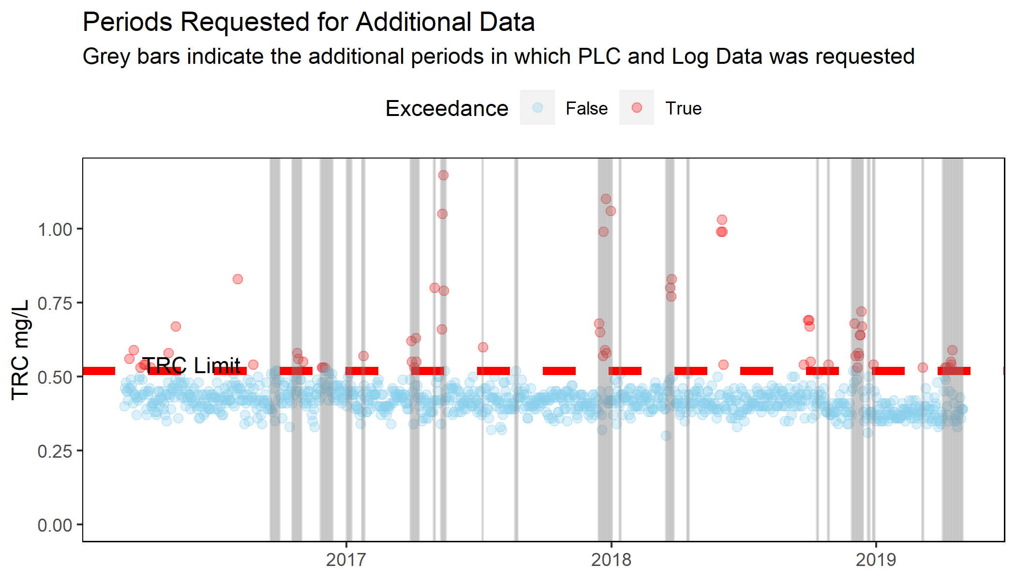

Exceedance (of 0.52 mg/L target)

Figure 2-1 Timeframes for Detailed Data Evaluation

Examples of evaluations from these specific periods can be found in **Section 3**.

Table 2-2 Timeframes for Detailed Data Evaluation

| Period | PLC & Log Data Request |
| --- | --- |
| 1 | 09/18/2016 - 10/01/2016 |
| 2 | 10/18/2016 - 10/31/2016 |
| 3 | 11/26/2016 - 12/13/2016 |
| 4 | 01/01/2017 - 01/08/2017 |
| 5 | 01/22/2017 - 01/26/2017 |
| 6 | 03/30/2017 - 04/11/2017 |
| 7 | 05/01/2017 - 05/03/2017 |
| 8 | 05/11/2017 - 05/18/2017 |
| 9 | 07/07/2017 - 07/08/2017 |
| 10 | 08/21/2017 - 08/25/2017 |
| 11 | 12/14/2017 - 01/02/2018 |
| 12 | 01/12/2018 - 01/14/2018 |
| 13 | 03/17/2018 - 03/28/2018 |
| 14 | 04/15/2018 - 04/18/2018 |
| 15 | 10/11/2018 - 10/13/2018 |
| 16 | 10/26/2018 - 10/28/2018 |
| 17 | 11/28/2018 - 12/14/2018 |
| 18 | 12/20/2018 - 12/23/2018 |
| 19 | 12/27/2018 - 12/30/2018 |
| 20 | 03/05/2019 - 03/07/2019 |
| 21 | 04/02/2019 - 04/30/2019 |

Data in **Table 2-3** is summarized by mean and standard deviation to provide insight into sample spreads. Plant performance may have changed during the 4-year period of data provided. Notable periods include the *Period of Performance* – 12-month period during which the facility targeted the proposed new TRC limit of 0.53 mg/L while maintaining required bacterial effluent concentrations, and *Post-Chlorination Upgrade* – period after new chlorination system upgrades were constructed and fully operational. Due to these distinct operating periods, three facets of statistics are provided for this dataset summarizing information from:

* Entire dataset (Data Ranges specified in **Table 2-2**)
* Period of Performance (11/1/2015 - 11/1/2016) (See **Table 2-3** footnote)

Table 2-3 Detailed Data Provided by PLC Logs

| Parameter | Sample Count | | Mean | | Standard Deviation | |
| --- | --- | --- | --- | --- | --- | --- |
| All Data[1] | Period of Performance[2] | All Data[1] | Period of Performance[2] | All Data[1] | Period of Performance[2] |
| Calculated.Hypo.Dose GPH | 251,751 | 40,117 | 15.8 | 14.5 | 11.5 | 6.9 |
| CDM_Calculated_Dose GPH[[3] | 251,753 | 40,118 | 15.7 | 14.4 | 11.3 | 6.7 |
| CDM_Calculated_Dose mg/L[3] | 60,531 | 10,770 | 2.9 | 2.2 | 4.8 | 1.3 |
| CDM Calculated Chlorine Demand.mg/L(Prominent) | 251,753 | 40,118 | 0.3 | 0.4 | 0.6 | 0.5 |
| Diffuser Dose (mg/L) | 251,751 | 40,117 | 1.8 | 2.6 | 0.6 | 0.7 |
| Effluent Flow MGD | 251,751 | 40,117 | 28.7 | 20.0 | 16.8 | 8.6 |
| Emergency Tank Level (gallons) | 251,751 | 40,117 | 972.1 | 998.1 | 117.3 | 53.8 |
| FI.001 (MSP 1 flow MGD) | 251,753 | 40,118 | 5.6 | 1.1 | 10.6 | 5.4 |
| FI.002 (MSP 2 flow MGD) | 251,753 | 40,118 | 5.8 | 6.7 | 10.7 | 11.4 |
| FI.003 (MSP 3 flow MGD) | 251,753 | 40,118 | 5.9 | 10.6 | 10.8 | 13.2 |
| FI.004 (MSP 4 flow MGD) | 251,753 | 40,118 | 9.9 | 4.9 | 12.6 | 9.9 |
| FI.005 (MSP 5 flow MGD) | 251,753 | 40,118 | 5.1 | 4.7 | 10.0 | 10.0 |
| FI.006 (MSP 6 flow MGD) | 251,753 | 40,118 | 4.7 | 2.4 | 10.1 | 7.6 |
| Hypo Flow gph | 251,751 | 40,117 | 16.6 | 14.5 | 11.2 | 7.0 |
| Influent Flow MGD | 251,753 | 40,118 | 37.0 | 30.4 | 16.9 | 9.4 |
| Mixer Dose (mg/L) | 251,751 | 40,117 | 1.5 | 1.7 | 1.2 | 0.3 |
| PI.4210.GPH | 251,751 | 40,117 | 3.9 | 1.1 | 12.7 | 6.0 |
| PI.4211.GPH | 251,751 | 40,117 | 0.6 | 0.2 | 5.6 | 3.5 |
| PI.4212.GPH | 251,751 | 40,117 | 8.7 | 13.1 | 7.0 | 4.3 |
| PI.4213.GPH | 251,751 | 40,117 | 1.1 | 0.0 | 3.6 | 0.1 |
| PI.4214.GPH | 251,751 | 40,117 | 1.3 | 0.0 | 4.3 | 0.6 |
| Prominent Effluent.Cl.Res (mg/L) | 251,751 | 40,117 | 0.6 | 0.5 | 0.6 | 0.5 |
| Prominent Influent Cl.Res (mg/L) | 251,751 | 40,117 | 0.9 | 0.9 | 0.4 | 0.2 |
| Tank.4201.Level (gallons) | 251,751 | 40,117 | 4,481.7 | 2,911.7 | 2,025.7 | 1,212.0 |
| Tank.4202.Level (gallons) | 251,751 | 40,117 | 5,276.3 | 6,195.1 | 1,949.4 | 956.1 |
| Tank.4203.Level (gallons) | 251,751 | 40,117 | 5,121.6 | 6,100.9 | 2,138.2 | 190.5 |
| Total MSP Flow MGD | 251,753 | 40,118 | 37.0 | 30.4 | 16.9 | 9.4 |
| Total PI Pump Flow (Hypo GPH) | 251,753 | 40,118 | 15.6 | 14.4 | 11.5 | 7.2 |
| Total Tank Level (gallons) | 251,753 | 40,118 | 15,851.7 | 16,205.4 | 2,783.7 | 1,785.0 |

[1] – Entire dataset provided for the periods 9/18/2016 - 4/18/2019

[2] – Period of Performance that overlaps with dataset includes 9/18/2016 – 11/1/2016

[3] – CDM calculated pump flow and dose based on 15% trade sodium hypochlorite solution and MSP flow rate

2.3 Process Logs

In addition to PLC data for the periods specified in **Table 2-2**, operator log sheets were provided. 228 log sheets that contain instrumentation readings as well as comments from operators regarding calibration checks, target dose changes, and notable weather conditions were transcribed for electronic use. Transcribed data is /summarized in **Table 2-4.** Similar to the PLC data, the periods summarized are for:

* Entire dataset (Data Ranges specified in **Table 2-1**)
* Period of Performance (11/1/2015 - 11/1/2016) (See **Table 2-1** footnote)
* Post-Chlorination Upgrade (All data after 3/1/2016)

Table 2-4 Disinfection Information from Process Logs

|  |  |  |  |  |  |  |
| --- | --- | --- | --- | --- | --- | --- |
| Parameter | Sample Count | | Mean | | Standard Deviation | |
| All Data[1] | Period of Performance[2] | All Data[1] | Period of Performance[2] | All Data[1] | Period of Performance[2] |
| Chlorine Demand.(HACH) (mg/L) | 4,851 | 807 | 0.4 | 0.5 | 0.5 | 0.3 |
| Eff.Flow.mgd | 4,850 | 806 | 27.7 | 20.4 | 15.1 | 8.9 |
| Hach effluent.(mg/L) | 4,850 | 806 | 0.5 | 0.5 | 0.3 | 0.2 |
| Hach Influent.(mg/L) | 4,850 | 807 | 0.9 | 0.9 | 0.5 | 0.3 |
| Mixer Dose.(mg/L) | 1,728 |  | 0.7 |  | 0.5 |  |
| Prominent Effluent.(mg/L) | 4,665 | 790 | 0.6 | 0.5 | 0.7 | 0.3 |
| Prominent Influent. (mg/L) | 4,833 | 800 | 0.9 | 0.9 | 0.5 | 0.2 |
| Total Pump flow GPH | 4,832 | 807 | 17.1 | 15.0 | 11.7 | 8.3 |

[1] – Entire dataset for process logs were collected and summarized for the periods 8/3/2016 - 12/16/2019. Process log data were only collected for specific chlorine events, the dates of these events

[2] – Period of Performance that overlaps with dataset includes 9/18/2016 – 11/1/2016

2.4 Visy Paper Data

The Port Richmond WRRF receives wastewater from a paper processing/recycling facility in Staten Island. Industrial waste has the potential to affect the quality and characteristics of sewage and can affect treatability, including disinfection. Data characterizing this facility’s wastewater was provided for the period of 1/1/2018 – 4/30/2019 and included daily flows, weekly BOD and CBOD grab samples, and sporadic results for other analytical parameters. The list of parameters and simple statistics are summarized in **Table 2-5.**

Table 2-5 Visy Paper Discharge Characteristics

| Parameter[1] | Sample Count | Mean | Standard Deviation |
| --- | --- | --- | --- |
| Benzene (Lbs/Day) | 1 | 25,457 | - |
| Biochemical Oxygen Demand (Lbs/Day) | 66 | 34,168 | 9,497.3 |
| Cadmium (mg/L) | 7 | 0 | 0.0 |
| Carbonaceous Biochemical Oxygen Demand (Lbs/Day) | 66 | 31,921 | 8,268.8 |
| Chromium (Hexavalent)(mg/L) | 7 | 1 | 1.9 |
| Chromium (Total) (mg/L) | 8 | 0 | 0.0 |
| Copper (mg/L) | 8 | 0 | 0.0 |
| Cyanide (Total) (mg/L) | 9 | 0 | 0.0 |
| Daily Flow (GPD) | 512 | 625,485 | 139,416.8 |
| Lead (mg/L) | 8 | 0 | 0.0 |
| Mercury (mg/L) | 8 | 0 | 0.0 |
| Molybdenum (mg/L) | 8 | 0 | 0.0 |
| Nickel (mg/L) | 8 | 0 | 0.0 |
| Non-Polar Material (mg/L) | 80 | 2 | 0.3 |
| Oil and Grease (mg/L) | 84 | 2 | 0.9 |
| Silver (mg/L) | 7 | 0 | 0.0 |
| Sulfates (mg/L) | 1 | 267 | - |
| Total Kjeldahl Nitrogen (Lbs/Day) | 14 | 85 | 36.9 |
| Total Suspended Solids (Lbs/Day) | 35 | 542 | 1,322.2 |
| Zinc (mg/L) | 8 | 0 | 0.1 |

[1]- Visy Paper data summary statistics from 1/1/2018 - 4/30/2019

Port Richmond noted filamentous growth at their facility on multiple occasions which may in part be associated with the discharge from Visy Paper, which is a high-strength, low-flow discharge. The Visy Paper waste stream is high in CBOD and low in nitrogen (CBOD:TKN ratio of 2,010:5) which can contribute to sludge bulking and filamentous growth due to high food-to-mass (F:M) ratio and limiting nutrients. Additional contributing factors can include insufficient dissolved oxygen, temperature, pH, and carbon source.

2.5 Sampling Program

2.5.1 Purpose and Scope

The purpose of sampling at the Port Richmond Wastewater Resource Recovery Facility (WRRF) is to characterize the variability of pathogen indicators in wastewater entering the facility, after primary treatment, after secondary treatment and after disinfection, to assess the impact of upstream processes upon disinfection effectiveness. Samples of chlorine contact tank (CCT) effluent, final tank effluent, primary effluent and plant influent were collected by Macan Deve Engineers (MDE) and transported to New York Environmental Consultants and Laboratories (NYE) where testing was conducted to assess disinfection. Field parameters and analysis performed included temperature, pH and total residual chlorine.

2.5.2 Testing

Samples of CCT effluent, final tank effluent, primary effluent and plant influent were collected daily (Monday through Friday) for a 12-day sampling period starting 6/29/2020 and ending 7/17/2020. Sampling was not performed on 7/2/2020 – 7/6/2020 due to the observation of July 4th holiday. Samples were collected from the sampling locations shown in **Figure 2-2,** moving sequentially from the effluent end of the CCT upstream to the plant influent; e.g., from the most highly treated sample location to untreated wastewater, and were transported by members of the field sampling team to NYE’s laboratory. See PW-TRC-PDR *Port Richmond WRRF Field Sampling Plan* for specific details on the sampling locations and sampling plan.

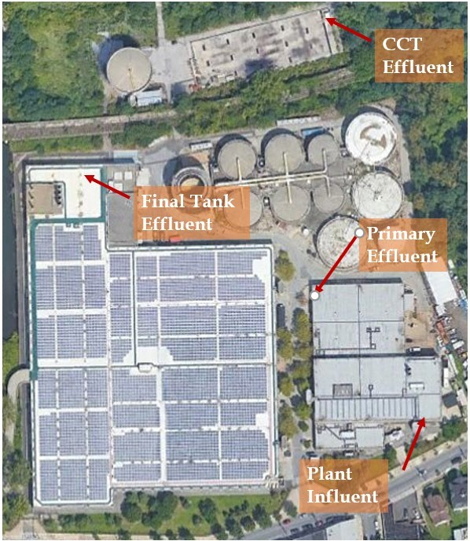

Figure Error! No text of specified style in document. - Port Richmond Sampling Locations

The 10-day sampling program was extended to 12 days to collect additional samples at each location and the full count of measurements is provided in **Table 2-6**. Results from one carbonaceous biological oxygen (cBOD) and one total suspended solids (TSS) sample were not analyzed as they exceeded their holding times during shipment. The fecal coliform samples collected on five days could not be used due to an apparent equipment malfunction at the NYE laboratory. Duplicate measurements of fecal coliform and enterococcus were collected at the final tank effluent for QA/QC and to capture supplementary data for the influent bacterial loading into the chlorine contact tanks. DEP provided additional data at the end of the sampling program for each of the days sampled including sludge volume index (SVI), sludge cylinder reading, and mixed liquor suspended solids (MLSS) concentrations.

Table 2-6 – Number of Samples Collected from Each Sample Location

|  |  |  |  |  |  |  |
| --- | --- | --- | --- | --- | --- | --- |
| Parameter | Parameter Abbreviation | Plant Influent | Primary Effluent | Final Tank Effluent | CCT Effluent | Aeration Tank Effluent |
| Fecal Coliform | FC | 12 | 12 | 24 | 12 | - |
| Enterococcus | EC | 12 | 12 | 24 | 12 | - |
| TSS | TSS | 12 | 12 | 12 | 12 | - |
| cBOD | cBOD | 12 | 12 | 12 | 12 | - |
| Lab TRC[1] | LTRC | - | - | 2 | - | - |
| Particle Size Distribution XAD | XAD | - | - | - | - | 2 |
| pH | pH | 12 | 12 | 12 | 12 | - |
| Temperature | T | 12 | 12 | 12 | 12 | - |
| Field TRC | FTRC | 12 | 12 | 12 | 12 | - |
| SVI | SVI | - | - | - | - | 12 |
| MLSS | MLSS | - | - | - | - | 9 |
| Cylinder Reading Average | CRA | - | - | - | - | 12 |
| Flow | Flow | 12 | - | - | - | - |

[1] – Lab TRC represents 5-gallon sample taken to perform chlorine demand test

2.5.3 Sampling Program Results

Sampling and analytical results for pathogen indicators, TRC, cBOD, TSS, chlorine demand testing, particle size distribution and mixed liquor suspended solids (MLSS), plant flow and SVI are all discussed. DEP provided notes for each of the sampling days which include information pertinent to plant performance and disinfection. Process control information on chlorine target residual was provided. The target residual was increased three times throughout the 12-days of sampling program. During the initial days of the sampling program, DEP maintained a residual target of 0.25 mg/L which is relatively low in comparison to the residual target of 0.4 mg/L identified in Port Richmond’s historical daily monitoring reports (DMRs). The residual target was increased to 0.35 mg/L on July 7th (the 4th sampling day) and then to 1 mg/L on July 10th (the 7th sampling day). This residual target increase is likely due to the relatively high effluent bacteria concentrations observed the days prior. The residual target was reduced to 0.45 mg/L on July 13th (the 8th sampling day) where it stayed for the remainder of the program.

Another chlorine application point at Port Richmond is within the returned activated sludge (RAS). RAS is chlorinated to mitigate bulking sludge and filamentous organism growth that may be caused by poor aeration control. DEP has provided information on RAS chlorination and during the first four sampling days, the chlorine dose was relatively high at 8.8 mg/L. This may explain why the TRC target was reduced to 0.25 mg/L. RAS chlorination was reduced to 6.3 mg/L on the 4th day of sampling (and the chlorine residual target was increased to 0.35 mg/L) and then dropped to 0 mg/L from the 8th day onward. Additional details on foaming, precipitation, and other notes can be found in **Table 2-7.**

|  |  |  |  |  |  |  |  |  |
| --- | --- | --- | --- | --- | --- | --- | --- | --- |
| Day | Date | TRC Target | RAS Chlor | Foaming | Rain Day | Contractor work* | MLSS | Notes |
| (mg/L) | Dose (mg/L) | Condition | (Yes/No) | (mg/L) |
| 1 | 6/29/2020 | 0.25 | 8.8 | Heavy | No | -- | 1160 | Experienced foaming as a result of M. Parvicella filaments |
| 2 | 6/30/2020 | 0.25 | 8.8 | Heavy | No | Yes | 1070 | Contractor work on June 30th and July 14th required the primary sludge pumping to be off during the sampling time period which may have affected the quality of primary effluent. |
| 3 | 7/1/2020 | 0.25 | 8.8 | Heavy | Yes | -- | 980 |  |
| (NO SAMPLING) | 7/2/2020 | 0.25 | 8.8 | Heavy | Yes | -- | 800 |  |
| 4 | 7/7/2020 | 0.35 | 6.3 | Medium | No | -- | 1020 |  |
| 5 | 7/8/2020 | 0.35 | 6.3 | Medium | No | -- | 780 |  |
| 6 | 7/9/2020 | 0.35 | 6.3 | Light | No | -- | 670 |  |
| 7 | 7/10/2020 | 0.35 to 1.0 | 6.3 | Light | Yes | -- | 560 |  |
| 8 | 7/13/2020 | 0.45 | Off | None | No | -- | 770 |  |
| 9 | 7/14/2020 | 0.45 | Off | None | No | Yes | 765 | Contractor work on June 30th and July 14th required the primary sludge pumping to be off during the sampling time period which may have affected the quality of primary effluent. |
| 10 | 7/15/2020 | 0.45 | Off | None | No | -- | 760 |  |
| 11 | 7/16/2020 | 0.45 | Off | None | No | -- | 770 |  |
| 12 | 7/17/2020 | 0.45 | Off | None | No | -- | 780 |  |

Table 2-7 – DEP Sampling Program Notes

2.5.3.1 Bacterial Results

Treated effluent from the Port Richmond WRRF discharges to the Kill Van Kull, which is identified as a Class SD water by the Department of Environmental Conservation (DEC). The best usage of Class SD waters is fishing. Class SD waters must be suitable for fish, shellfish and wildlife survival and the water quality shall be suitable for primary and secondary contact recreation, although other factors may limit these uses. New York State also identifies that Class SD waters may not meet the requirements for fish propagation due to natural or man-made conditions.

The existing DEC State Pollutant Discharge Elimination System (SPDES) discharge permits for all fourteen of the City’s WRRFs require year-round disinfection and include limits for fecal coliform. Port Richmond WWTP SPDES permit NY0026107 includes the following effluent limits for fecal coliform:

30-day geometric mean fecal coliform: 200/100 mL

7-day geometric mean fecal coliform: 400/100 mL

6-hour geometric mean fecal coliform 800/100 mL

Instantaneous maximum fecal coliform: 2400/100 mL

In November 2012, EPA published the 2012 recreational water quality criteria (RWQC) recommendations which recommended the use of enterococcus as a pathogenic indicator organism for marine recreational waters. The 2012 RWQC includes both a geometric mean and a statistical threshold value (STV); it also defines a magnitude, duration and frequency of excursion for both the geometric mean and the STV specifically for enterococcus.

The anticipated future permit requirement for enterococcus from the 2012 RWC is as follows:

Recommendation based on estimated illness rate of 36/1000:

30-day geometric mean fecal coliform: 35/100 mL

Statistical threshold value: 130 /100mL

Recommendation based on estimated illness rate of 32/1000:

30-day geometric mean fecal coliform: 30/100 mL

Statistical threshold value: 110/100mL

Results for fecal coliform and enterococcus at each sampling location are presented as a time series in **Figure 2-3** (two values are shown for final tank effluent each day, as duplicate samples were collected and analyzed). **Figure 2-4** provides a box plot distribution of these bacterial concentrations at each location to show the variability of bacterial concentrations observed.

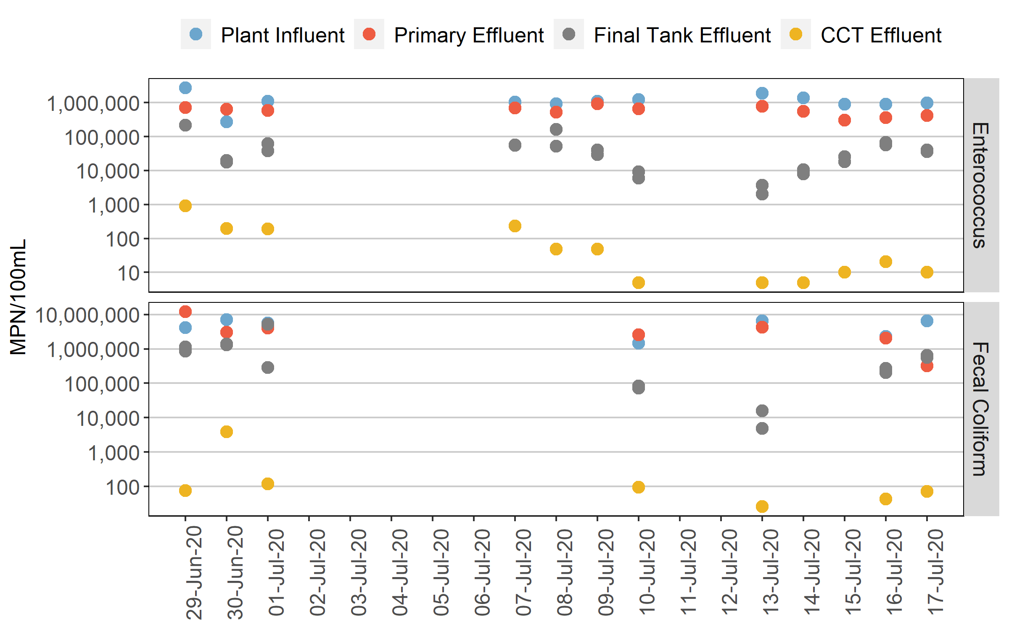

Figure Error! No text of specified style in document.2-3 – Port Richmond Bacterial Concentrations Sampling Time Series

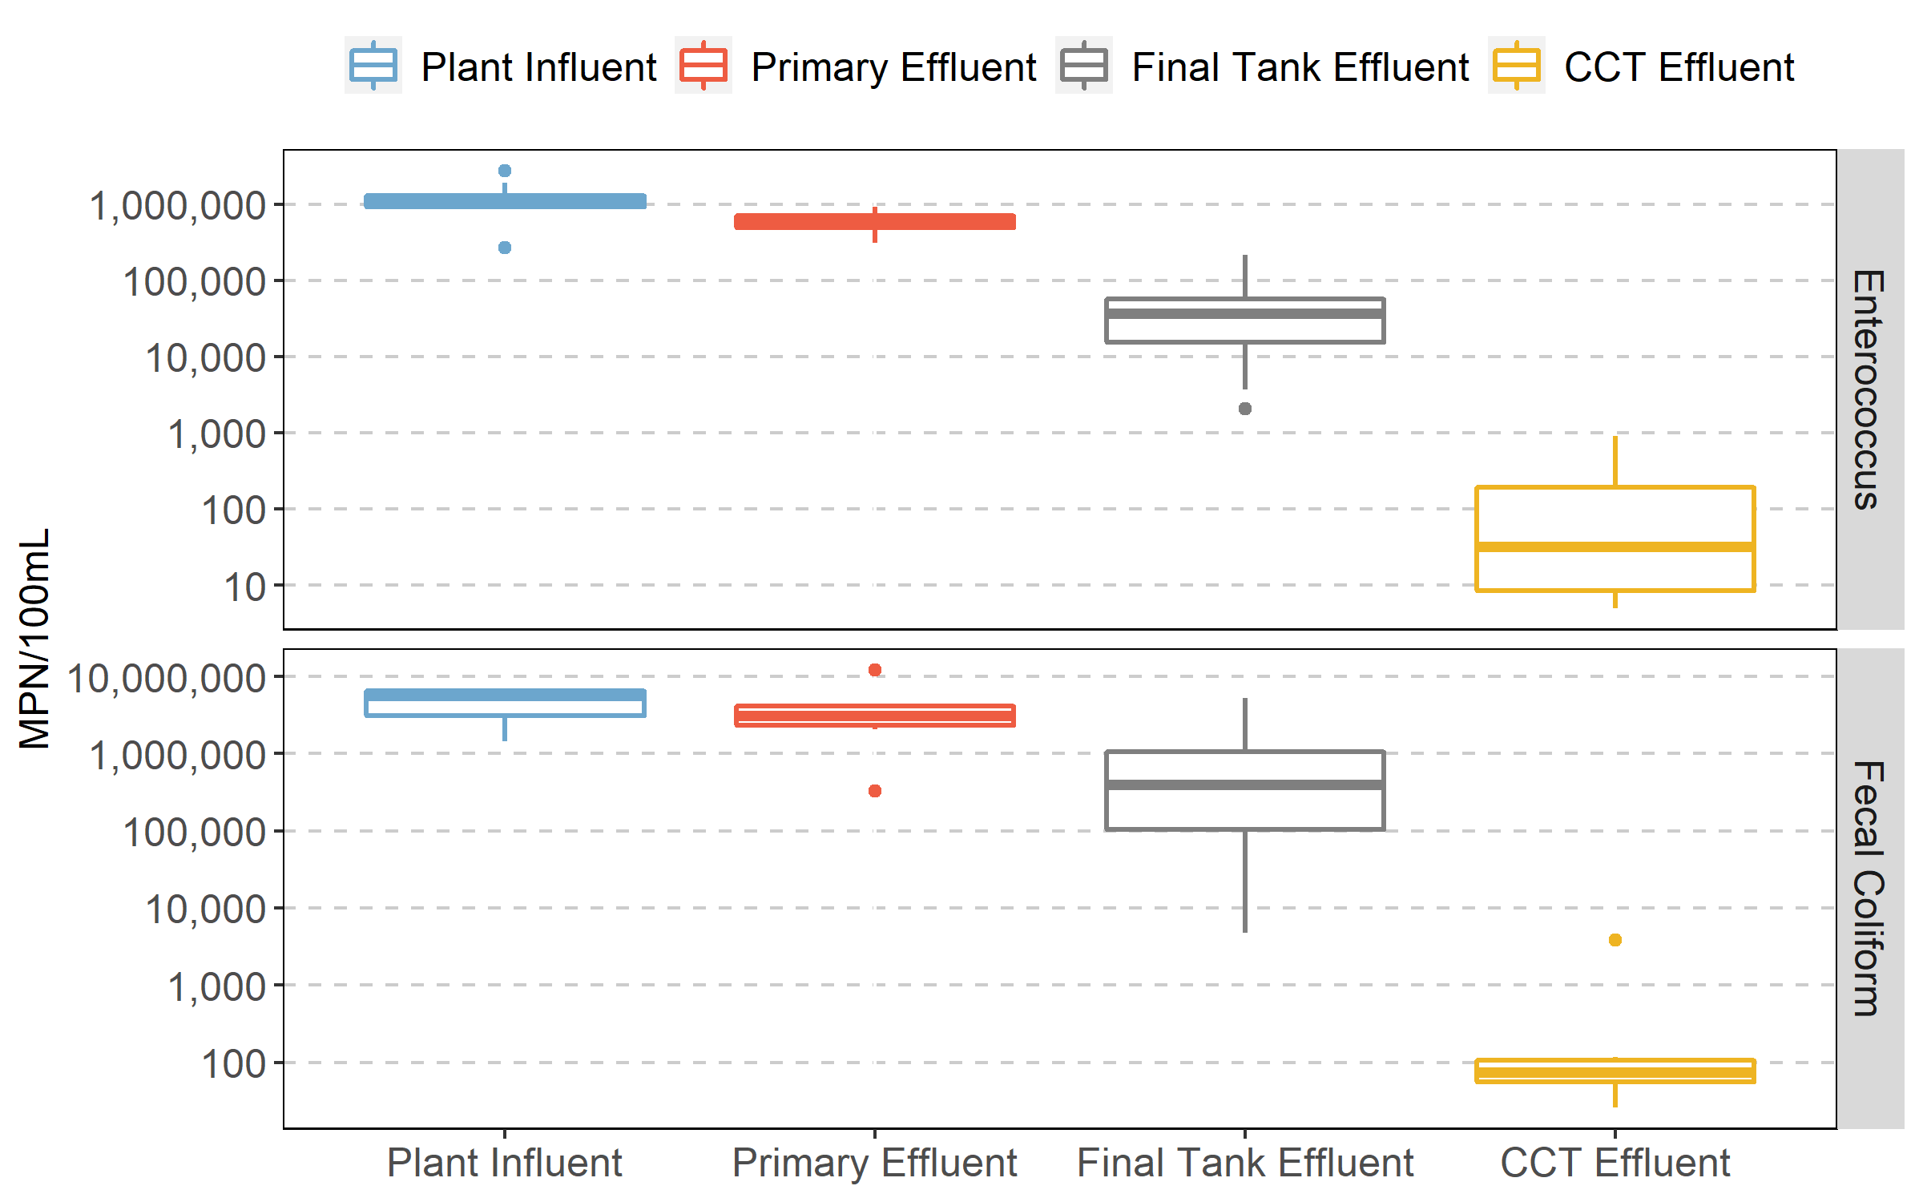

Figure 2-4 Port Richmond Bacterial Concentration Distributions by Location

Throughout the 12-day sampling period, the influent bacterial concentrations to the facility were consistent, except for the first day of sampling when the enterococcus concentration reached 2.68 x105 MPN/100mL. No significant reduction in bacterial concentrations resulted from primary treatment (red and blue dots).

The reduction in bacterial concentrations across secondary treatment varied during this sampling program, such that concentration in the CCT influent varied by more than two orders of magnitude, with CCT influent enterococcus between 103 – 105 MPN/100mL and CCT influent fecal coliform between 104 – 106. Such variability can significantly impact disinfection performance, requiring a higher residual in order to maintain the desired log reduction for the maximum bacterial concentration. **Table 2-8** presents summary statistics of CCT influent and effluent bacterial concentrations. For reference, historical bacterial concentrations are also presented from Port Richmond’s DMRs.

Table 2-8 – Summary Statistics of Port Richmond Bacterial Concentrations

|  |  |  |  |  |
| --- | --- | --- | --- | --- |
| Parameter | Final Tank Effluent Enterococcus (MPN/100mL) | Final Tank Effluent Coliform (MPN/100mL) | CCT Effluent Enterococcus (MPN/100mL) | CCT Effluent Fecal Coliform (MPN/100mL) |
| [Historical 3/1/2016 – 4/30/2020]  (Sampling Program 6/29/2020 – 7/17/2020) | | | |
| Sample Count | NA/12 | NA/7 | 38/12 | 1,159/7 |
| Min | NA/2,875 | NA/10,300 | 1/5 | 1/26 |
| 2nd Percentile | NA/3,926 | NA/18,406 | 1/5 | 2/28 |
| Geomean | NA/29,582 | NA/330,504 | 4/36 | 45/114 |
| 98th Percentile | NA/139,384 | NA/2,588,280 | 473/761 | 1,297/3,402 |
| Max | 217,600 | 2,758,500 | 1020/910 | 4,000/3,850 |

[1] –The first value represents historical data and the second value represents 2020 sampling program statistics

2.5.3.2 TRC, cBOD and TSS Results

Results for TRC, cBOD and TSS are presented on **Figure 2-5** as a time series plot throughout the sampling program duration. **Figure 2-6** shows the distribution of this data at each sampling location. Chlorine residual was measured at each location using the Hach DR2800. However, high turbidity and color can lead to inaccuracy in the results from the DPD method, as well as the presence of other oxidizing agents. This is the suspected explanation for the Hach DR2800 instrument measuring chlorine residual in the plant influent. This high strength wastewater is expected to have no chlorine residual. Chlorine residual is more likely to occur downstream of the plant influent where chlorinated RAS may be recycled.

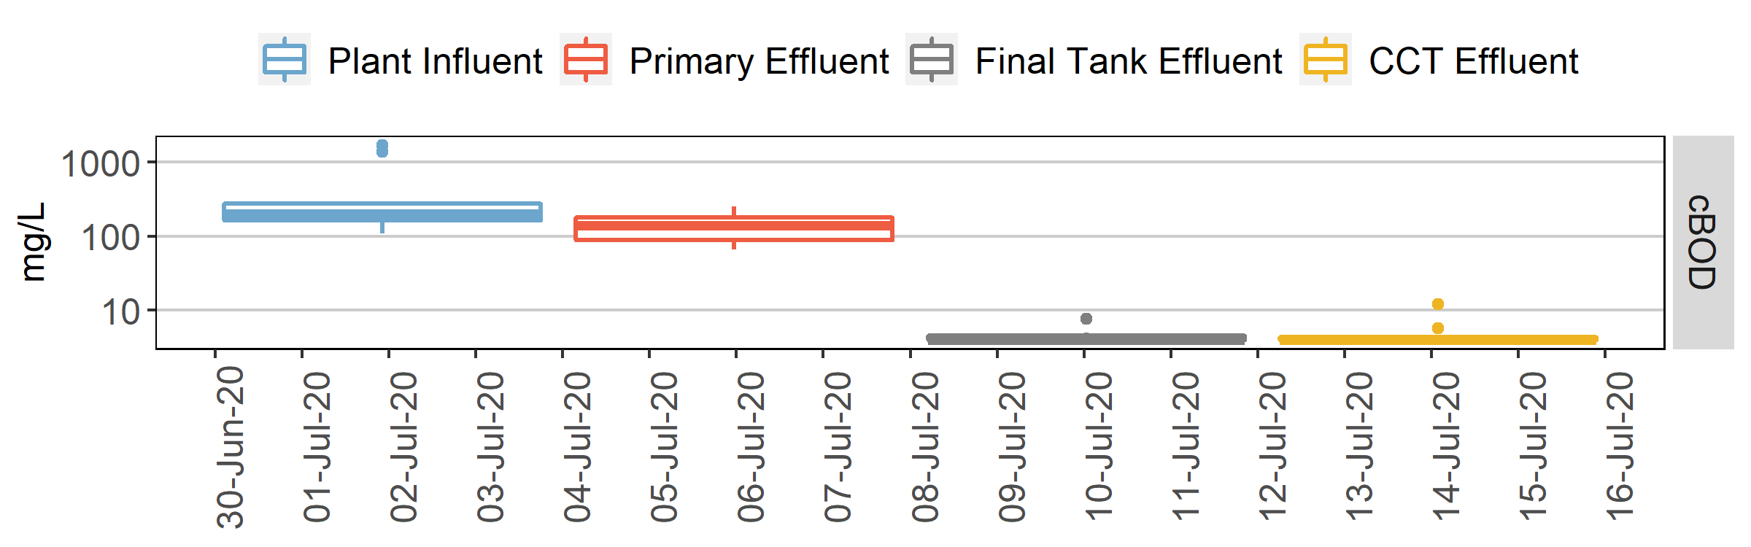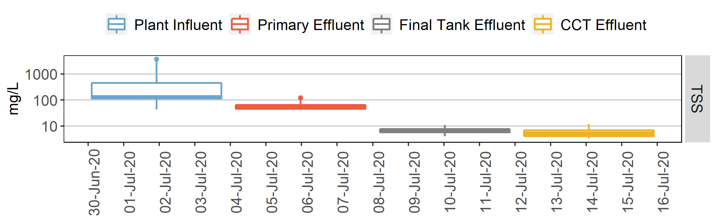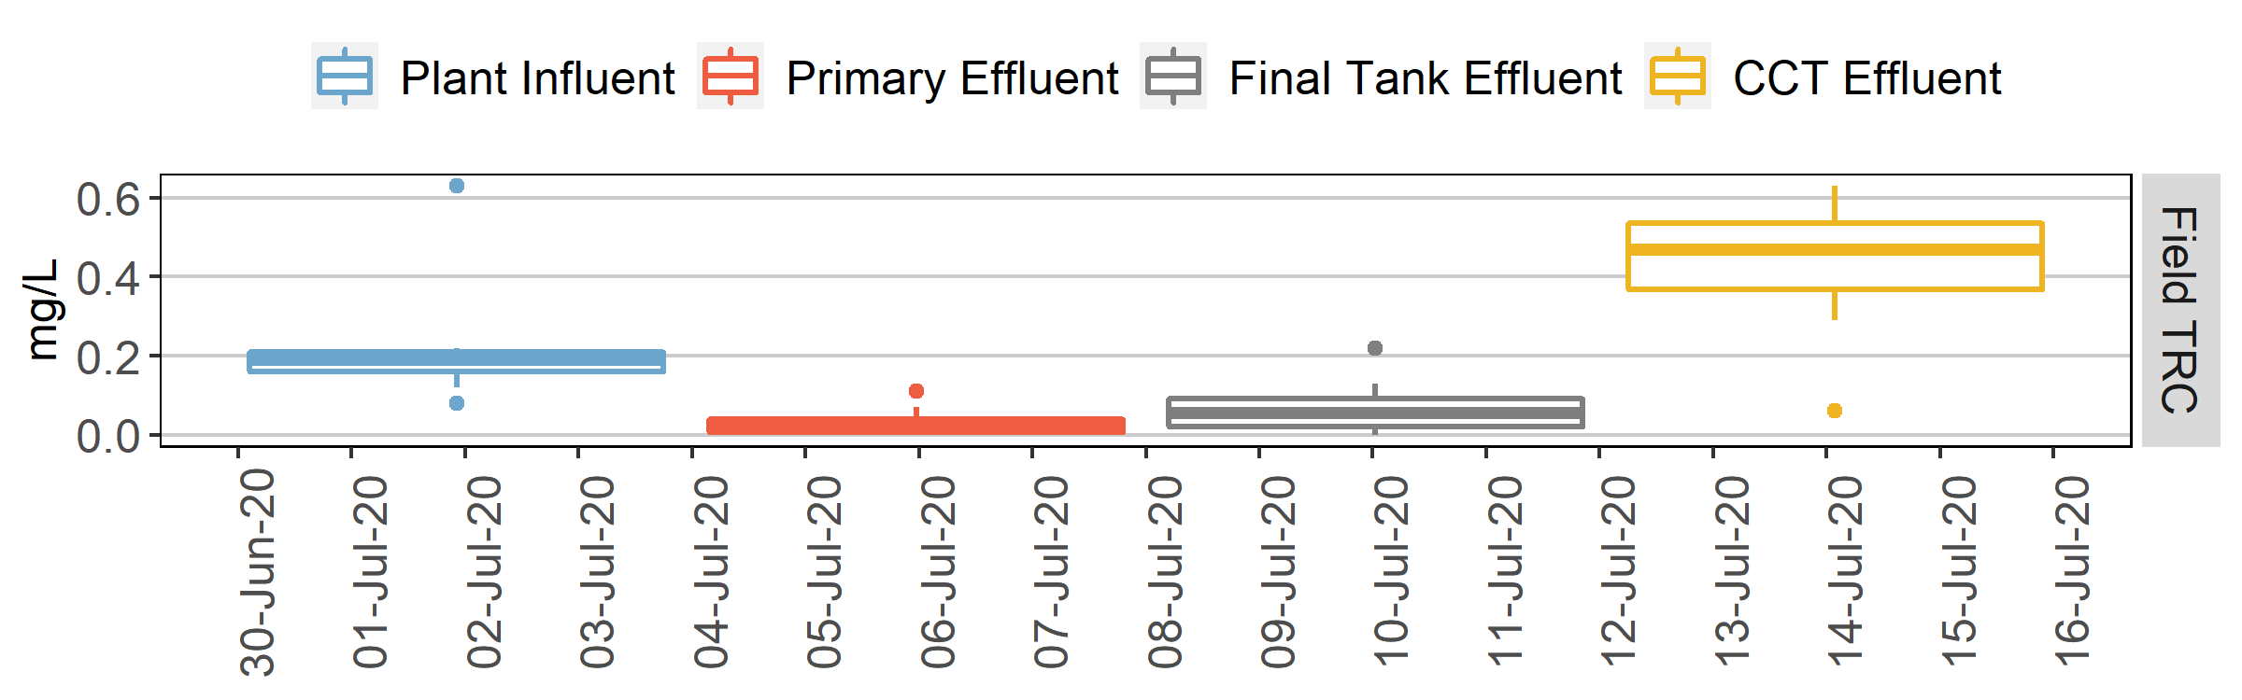

Figure 2-6 - Port Richmond cBOD, TSS, and TRC Concentrations by Location

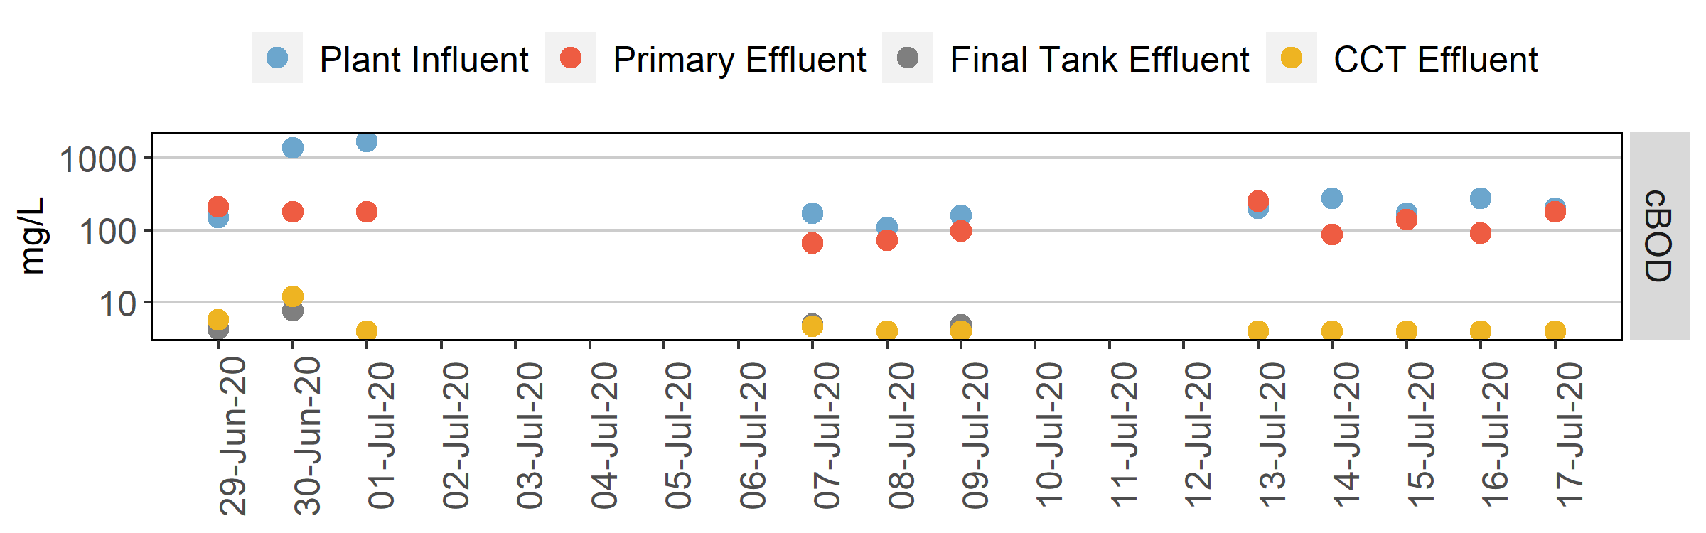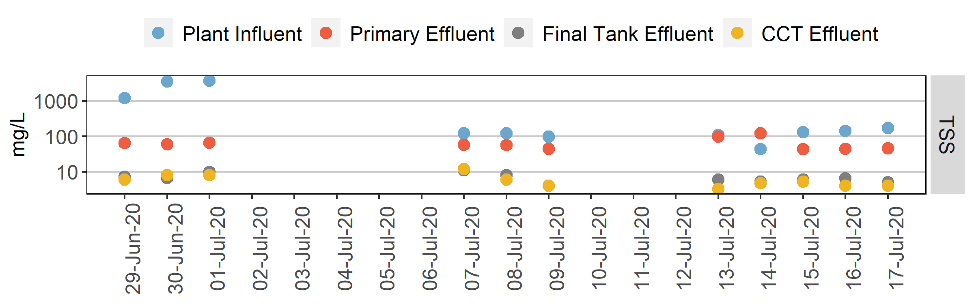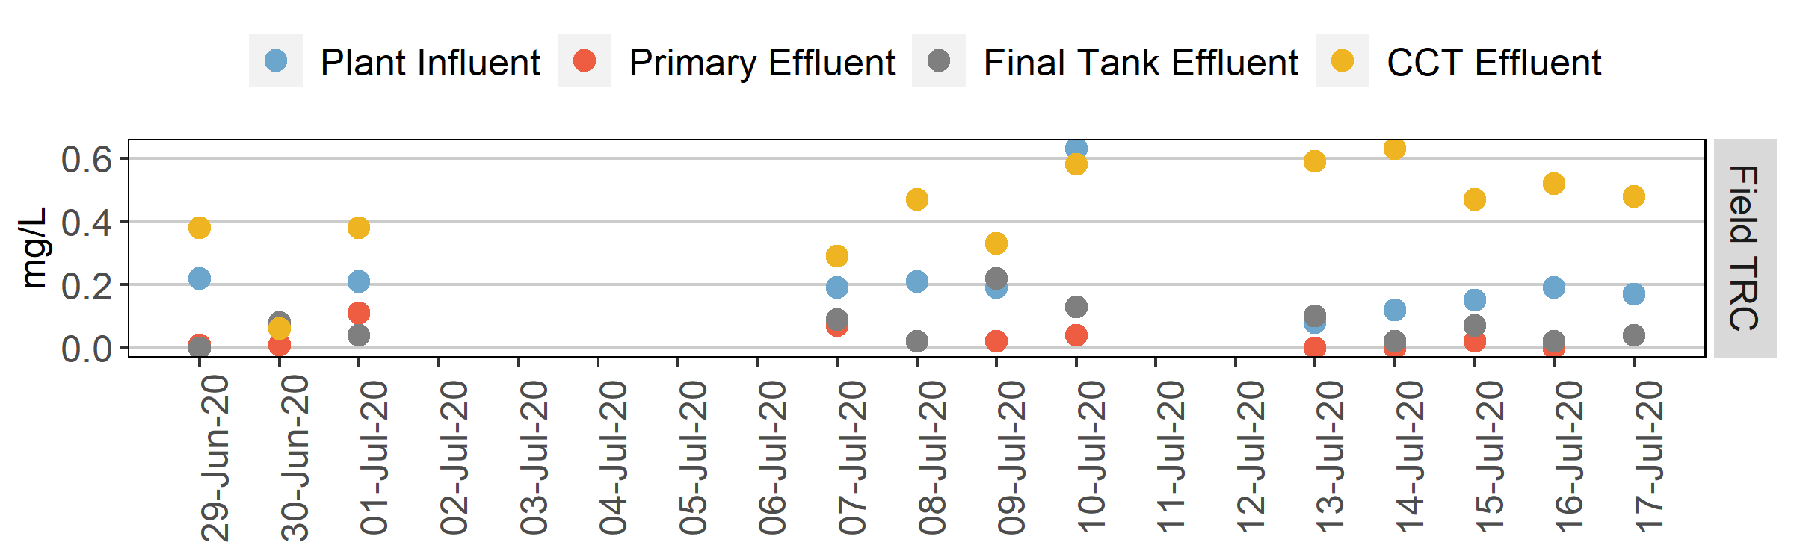

Figure Error! No text of specified style in document.2-5 - Port Richmond cBOD, TSS, and TRC Concentrations Sampling Time Series

During the first three days of sampling, both influent cBOD and TSS exceeded 1,000 mg/L. Two extremely high influent TSS samples were observed on the second and third day of sampling with influent measurements of 3,500 mg/L and 4,000 mg/L respectively. As shown in **Table 2-9**, historically, Port Richmond has never reported a daily average value this high, however the DMR data provides daily average composite samples while the sampling program is based on a single grab sample. (Port Richmond AT sheets did report an influent TSS concentration of 1,543 mg/L on July 20th, after this characterization program had been completed.) The cBOD values for that day were high as well possibly due to the particulate fraction from a high TSS sample.

The June and July Pratt Paper **Daily Effluent Analysis** provided TSS and cBOD concentrations and loads for six days during June and four days during July, none of which coincided with the June 29th through July 1st samplingperiod when the high TSS and cBOD concentrations were measured in the influent grab samples. The reported average cBOD concentrations for the months of June and July exceeded 6,000 mg/L. The reported average TSS concentrations were 60 and 66 mg/L for June and July respectively, both considerably lower than the observed influent TSS concentrations at the plant.

Pratt Paper’s reported average daily cBOD load for July was 30,498 lbs/day, while Port Richmond reported an average daily cBOD load of 71,681 lbs/day. However, on July 15th, both Port Richmond and Pratt Paper reported influent CBOD loads; on that day the reported Pratt Paper cBOD load was 27,759 lbs/day, while the reported Port Richmond load was 13,894 lbs/day (see Process sheet, cBOD influent loading). This discrepancy is presumably attributed to different sampling times, but indicates that Pratt Paper likely comprised most of the cBOD loading to the plant on that day.

The distribution of effluent TRCs throughout the sampling program was consistent with observations recorded historically in the DMRs – both with a mean residual of 0.43 mg/L.

Table 2-9 Summary Statistics of Port Richmond cBOD, TSS, and TRC Concentrations

| Parameter | Influent CBOD (mg/L) | Influent TSS (mg/L) | Effluent CBOD (mg/L) | Effluent TSS (mg/L) | Effluent TRC (mg/L) |
| --- | --- | --- | --- | --- | --- |
| [Historical 3/1/2016 – 4/30/2020]  (Sampling Program 6/29/2020 – 7/17/2020) | | | | |
| Sample Count | 1,160/11 | 1,160/11 | 1,160/11 | 2,298/11 | 1,16012 |
| Min | 57.0/110 | 59/43 | 0.0/4.0 | 1.0/3.3 | 0.30/0.06 |
| 2nd Percentile | 137/118 | 81/54 | 3.0/4.0 | 2.5/3.4 | 0.34/0.11 |
| Mean | 331/438 | 170/843 | 9.5/4.9 | 8.2/5.9 | 0.43/0.43 |
| 98th Percentile | 610/1,640 | 388/3,660 | 34.8/10.7 | 35.1/11.2 | 0.65/0.62 |
| Max | 1,698,/1,700 | 2,000/3,700 | 132.0/12.0 | 166.0/12.0 | 1.18/0.63 |

[1] –The first value represents historical data and the second value represents 2020 sampling program statistics

[2] – Historical values are daily average composites while sampling program is based on one discrete sample per day

2.5.3.3 Chlorine Demand Testing

Variability in treated wastewater quality can impact the chlorine demand, resulting in corresponding variability in the required chlorine dose necessary to maintain bacteria inactivation. Conversely, if the applied chlorine dose is maintained high enough at a fixed dose to account for the maximum demand, then this variability in demand will result in a proportional variation in the effluent residual. While for wastewater effluents ammonia and nitrite have the greatest impact on chlorine demand, other organics and some inorganics (e.g., hydrogen sulfide, ferrous iron, and manganese) if present can impact the chlorine demand. Other factors affecting chlorine demand include temperature, pH, bacterial concentrations, and disinfection dose. Variability in factors that affect this demand can lead to complications in fine-tuning chlorine residual concentrations and resulting overdosing or underdosing. Port Richmond has several factors that can lead to variability in secondary effluent quality:

* Highly variable influent plant BOD loads affecting secondary treatment and causing inconsistent food to mass ratios, settling characteristics, and bulking in activated sludge;
* Variable CCT influent bacteria loads ranging between 104 – 106 MPN/100mL fecal coliform as observed throughout the sampling program; and
* Difficulty maintaining consistent dissolved oxygen levels throughout the aeration system leading to filamentous bacterial growth.

Two chlorine demand tests for this study were conducted on the 8th and 10th day of sampling. 5-gallons of final tank effluent were collected on each day and the demand tests were conducted at 20°±1°C. The study was conducted as follows (see **Port Richmond Sampling Program Memorandum** for the full chlorine demand procedure):

* Screening investigation – Dosing 5 chlorine doses between 0.5 and 3 mg/L based on historical dosing concentrations and residual measurement are recorded after 5 minutes of contact time;
* Residual interpolation – Interpolating TRC results from screening evaluation to determine the chlorine doses required to achieve target residual concentrations of 0.2, 0.4, 0.6, 0.8 and 1 mg/L. These target residual concentrations were selected based on historical residual concentrations from the facility’s DMRs, and
* True demand investigation – Conducting demand investigation using interpolated doses required to achieve desired chlorine residual concentrations. Residual is measured at 2 minutes of contact time to obtain initial demand and then at 30 minutes of contact time to emulate contact tank hydraulic residence times. This demand investigation is run twice to obtain duplicate results and ensure adequate QA/QC.

Results of the two chlorine demand tests are presented in **Table 2-10** and **Table 2-11**. Results confirm that the initial demand (2-minute contact time) consumes the majority of the chlorine. The resultant total residual chlorine after 30 minutes of contact time was expected based on the target residual. However, the dose to achieve the same target residual varied significantly between the two days and demand investigation 2 required an average 39% higher dose, indicative of the variable CCT influent quality. **Figure 2-7** and **Figure 2-8** show the demand difference between the two investigations. Influent bacterial concentrations of fecal coliforms during the sample day of investigations 1 and 2 were on the order of 103 and 104 MPN/100mL respectively.

2.5.3.4 Particle Size Distribution

Particle size distribution (PSD) can impact disinfection effectiveness by screening bacteria within the solids particle from the effects of the disinfectant, in this case chlorine. Studies have shown that effluents with larger PSDs, can require higher disinfectant dose or longer contact time in order to maintain the same level of inactivation as effluents with smaller PSDs. PSD analysis was conducted at Particle Technology Labs using Single Particle Optical Sensing (SPOS) technology. This analysis was conducted on two separate sampling days on aeration tank effluent. PSD provides information on solids size distributions which can give insight into bulking sludge or changes in solids sizes that may affect disinfection.

The distribution of solids sizes by % volume is presented in **Figure 2-9**. The results for the first particle size sampling event (July 13, day 8) shows a large fraction of particles between 20 and 200 µm with the distribution skewed heavily towards the larger particles in that range. This trend is consistent on the second particle size sampling event (July 15, day 10) as shown in **Figure 2-10**.

These results were compared to a PSD evaluation conducted in 2005; the results of the summer sampling event conducted July 2005 is presented in **Figure 2-11**. The 2005 distribution shows particle sizes ranging between 2.5 µm and 37.5 µm pointing towards a considerable increase in solids size over the past fifteen years, potentially resulting in wastewater that can become increasingly difficult to disinfect as the bacteria become entrained in the particles. The full particle size distribution report can be found in **Port Richmond Sampling Program Memorandum**.

2.5.3.5 Other Process Data

**Table 2-12** presents additional plant data and operational metrics that were provided by the DEP during this sampling period which include plant flow, SVI, and MLSS. Historical data from Port Richmond’s DMRs is also presented in **Table 2-12** for comparison. The facility was running at slightly lower flows and higher SVIs than typical. Average MLSS was running lower than typical for the facility which can affect secondary treatment performance and sludge quality.

|  |  |  |  |  |  |  |  |
| --- | --- | --- | --- | --- | --- | --- | --- |
| **Investigation 1 Screening** | | Table 2-10 - Demand Investigation 1 | | | | | |
| **(mg/L)** | | | | | |
| Starting Temperature C | Starting pH | **7/13/2020** | **Target TRC** | **Chlorine Dose** | **TRC - 2 min** | **TRC - 30 min** | **Demand** |
| 19 | 7.31 | Initial | 0.2 | 0.75 | 0.2 | 0.19 | 0.56 |
| **Chlorine Dose (mg/L)** | **TRC - 5 min (mg/L)** | 0.4 | 1.25 | 0.38 | 0.34 | 0.91 |
| 0.5 | 0.1 | 0.6 | 1.75 | 0.6 | 0.54 | 1.21 |
| 1 | 0.3 | 0.8 | 2.25 | 0.7 | 0.71 | 1.54 |
| 1.5 | 0.48 | 1 | 2.75 | 0.94 | 0.92 | 1.83 |
| 2 | 0.69 | Duplicate | 0.2 | 0.75 | 0.2 | 0.12 | 0.63 |
| 3 | 1.14 | 0.4 | 1.25 | 0.38 | 0.23 | 1.02 |
|  |  | 0.6 | 1.75 | 0.6 | 0.52 | 1.23 |
|  |  | 0.8 | 2.25 | 0.7 | 0.64 | 1.61 |
|  |  | 1 | 2.75 | 0.94 | 0.83 | 1.92 |

|  |  |  |  |  |  |  |  |
| --- | --- | --- | --- | --- | --- | --- | --- |
| **Investigation 2 Screening** | | Table 2-11 - Demand Investigation 2 | | | | | |
| **(mg/L)** | | | | | |
| Starting Temperature C | Starting pH | **7/15/2020** | **Target TRC** | **Chlorine Dose** | **TRC - 2 min** | **TRC - 30 min** | **Demand** |
| 19 | 7.18 | Initial | 0.2 | 1 | 0.24 | 0.18 | 0.82 |
| **Chlorine Dose (mg/L)** | **TRC - 5 min (mg/L)** | 0.4 | 2 | 0.4 | 0.32 | 1.68 |
| 0.5 | 0.12 | 0.6 | 3 | 0.6 | 0.49 | 2.51 |
| 1 | 0.17 | 0.8 | 4 | 0.91 | 0.73 | 3.27 |
| 1.5 | 0.29 | 1 | 5 | 3.73 | 1.06 | 3.94 |
| 2 | 0.42 | Duplicate | 0.2 | 1 | 0.24 | 0.17 | 0.83 |
| 3 | 0.51 | 0.4 | 2 | 0.36 | 0.3 | 1.7 |
|  |  | 0.6 | 3 | 0.56 | 0.42 | 2.58 |
|  |  | 0.8 | 4 | 0.9 | 0.71 | 3.29 |
|  |  | 1 | 5 | 3.92 | 0.92 | 4.08 |

Figure 2-7 – Investigation 1 Dose vs Demand

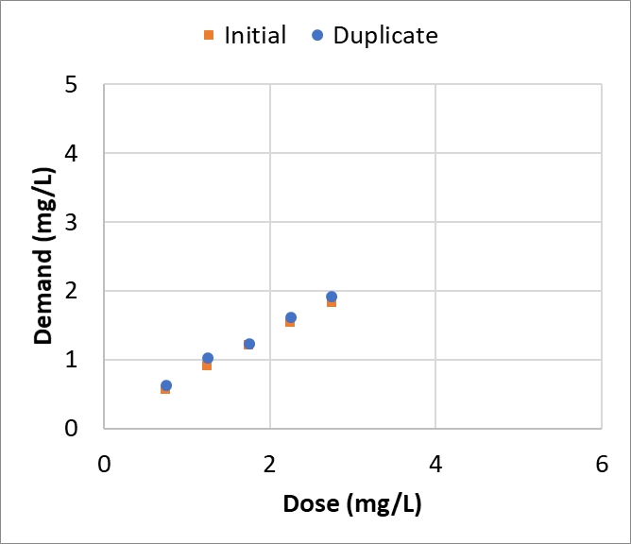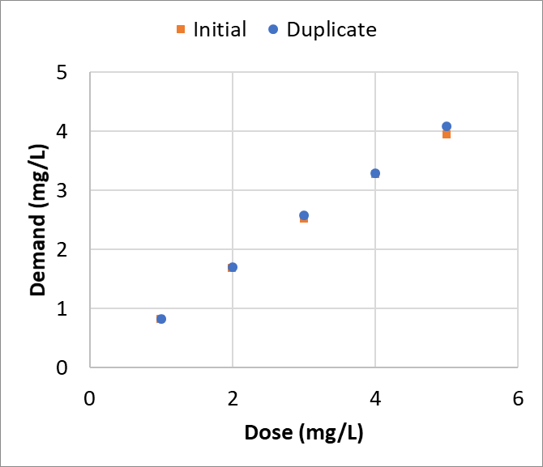

Figure 2-8 - Investigation 2 Dose vs Demand

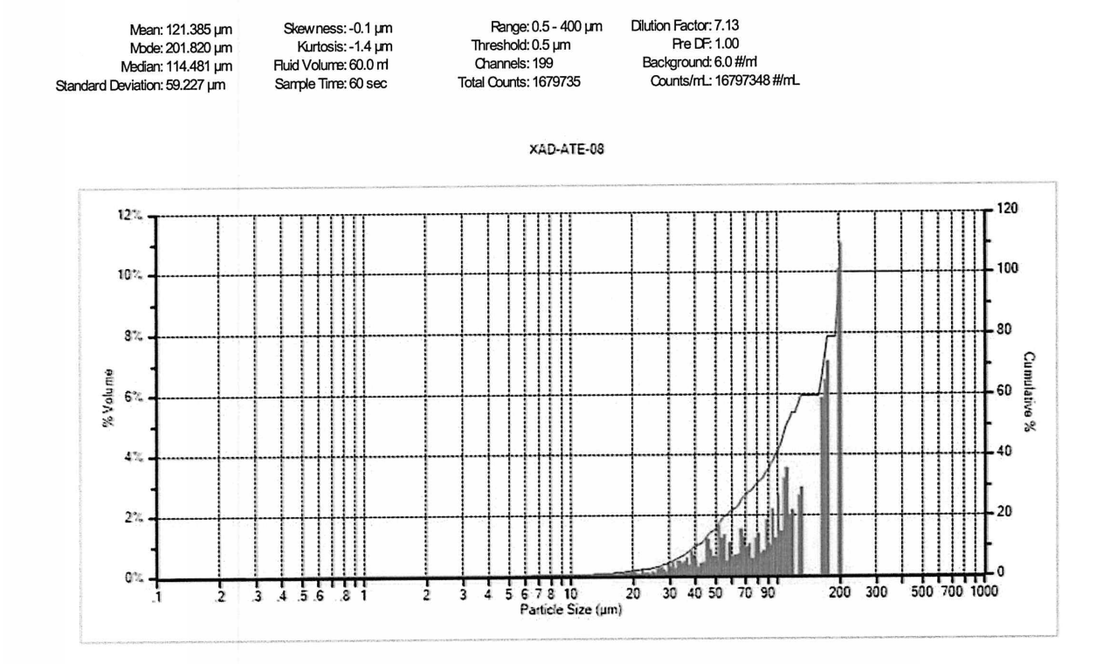

Figure 2-9 - Particle Size Distribution by Volume for Day 8 of 12

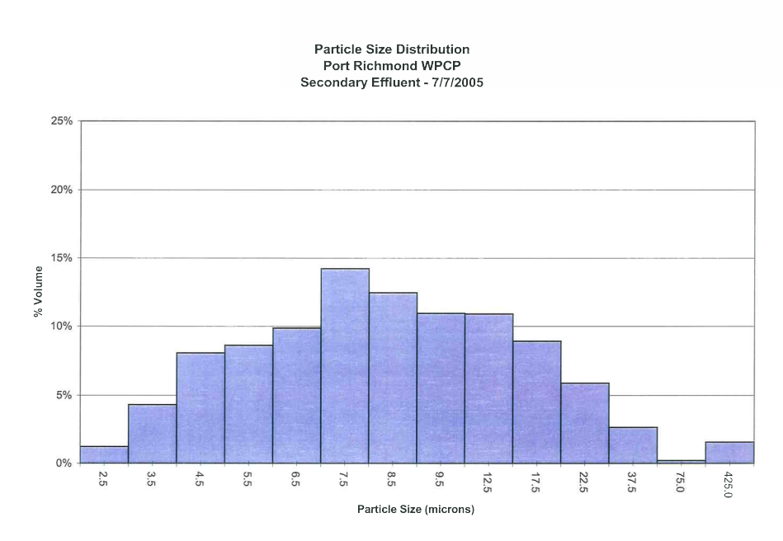

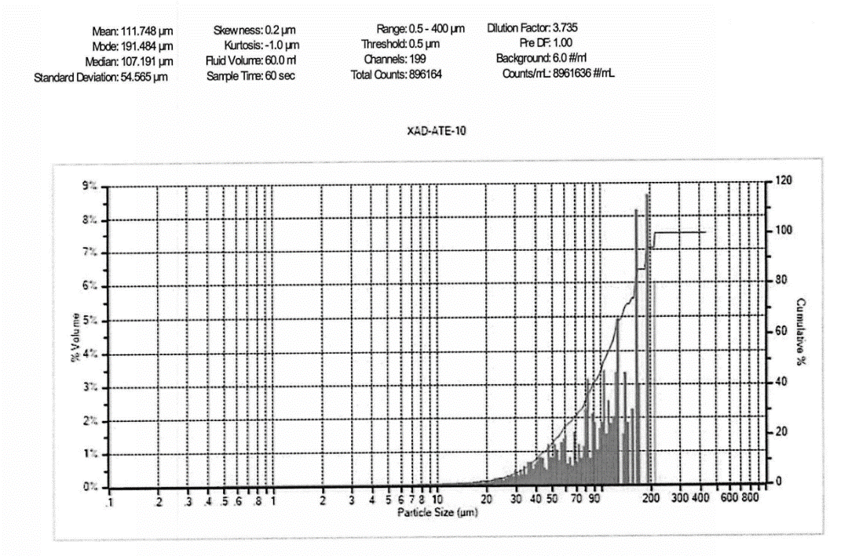

Figure 2-10 - Particle Size Distribution by Volume for Day 10 of 12

Figure 2-11 July 2005 Particle Size Distribution Results

Table 2-12 Additional DEP Operational Data

| Parameter | SVI | Aeration Tank MLSS (lb/d) | Flow (MGD) |
| --- | --- | --- | --- |
| [Historical 3/1/2016 – 4/30/2020]  (Sampling Program 6/29/2020 – 7/17/2020) | | |
| Sample Count | 655/12 | 657/12 | 1160/12 |
| Min | 40/7 | 475/560 | 15.0/18.0 |
| 2nd Percentile | 50/84 | 625/584 | 18.0/18.2 |
| Mean | 175/228 | 1,300/840 | 26.9/21.8 |
| 98th Percentile | 460/415 | 2,604/1,140 | 57.0/29.9 |
| Max | 690/423 | 3,330/1,160 | 95.0/31.0 |

[1] –[1] –The first value represents historical data and the second value represents 2020 sampling program statistics

2.5.4 Sampling Program Conclusions

The wastewater characterization sampling resulted in the following observations and conclusions:

* Influent bacterial concentrations and primary treatment were relatively consistent.
* Reduction of pathogen indicators across the secondary process is not consistent resulting in CCT influent concentrations that vary over two orders of magnitude.
* CBOD and TSS loading to the plant were significantly higher than typical sanitary wastewater (both exceeding 1,000 mg/L) on three of the days sampled. The plant reported heavy foaming and filamentous bacteria growth on those days, leading to high RAS chlorination.
* The plant seems to consider the impact of RAS chlorination when identifying target doses for disinfection.
* The particle size distribution results indicate a significant increase in solids sizes since 2005.

Section 3 Data EvaluationEach of the following factors that could potentially impact the chlorination process was evaluated using available data, as described in more detail below:

* Precipitation/Wet Weather events
* Process control challenges
* Discharge from Visy Paper
* Variation in chlorine demand ( based on influent wastewater characteristics and/or upstream process effectiveness)
* Return Activated Sludge (RAS)/Waste Activated Sludge (WAS) chlorination

Sodium hypochlorite use (e.g., age and strength)Data provided from BWT for the period from January 2014 through April 2019 was used to explore potential impacts from each of these factors. Effluent fecal coliform for the period of interest are shown on **Figure 3-1** and days where chlorine was exceeded are highlighted red.

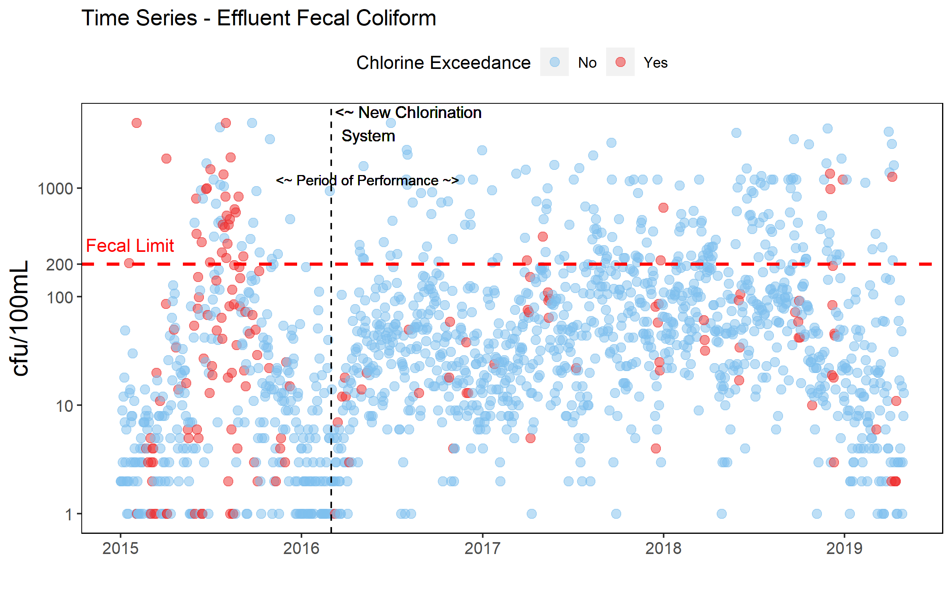

Figure 3-1 Effluent Fecal Coliform from 2015 through April 2019

The AT sheets, PLC data and process control logs were all reviewed for 21of the periods of high TRC after the new chlorination system was implemented in an effort to identify the underlying driving factors, as described below.

3.1 Precipitation/Wet Weather Events

Based on review of the twenty-one time periods of elevated effluent TRC that were evaluated in detail, ten (nearly half) of the events occurred on days where the plant reported precipitation. Wet weather coinciding with elevated effluent TRC is indicated on **Figure 3-2**. The dots indicate daily precipitation reported in inches, dots that are red indicate that TRC exceeded 0.52 mg/L and the blue dots indicate that TRC was below 0.52 mg/L. The figure also shows however, that elevated TRC also occurred with no precipitation impacts.

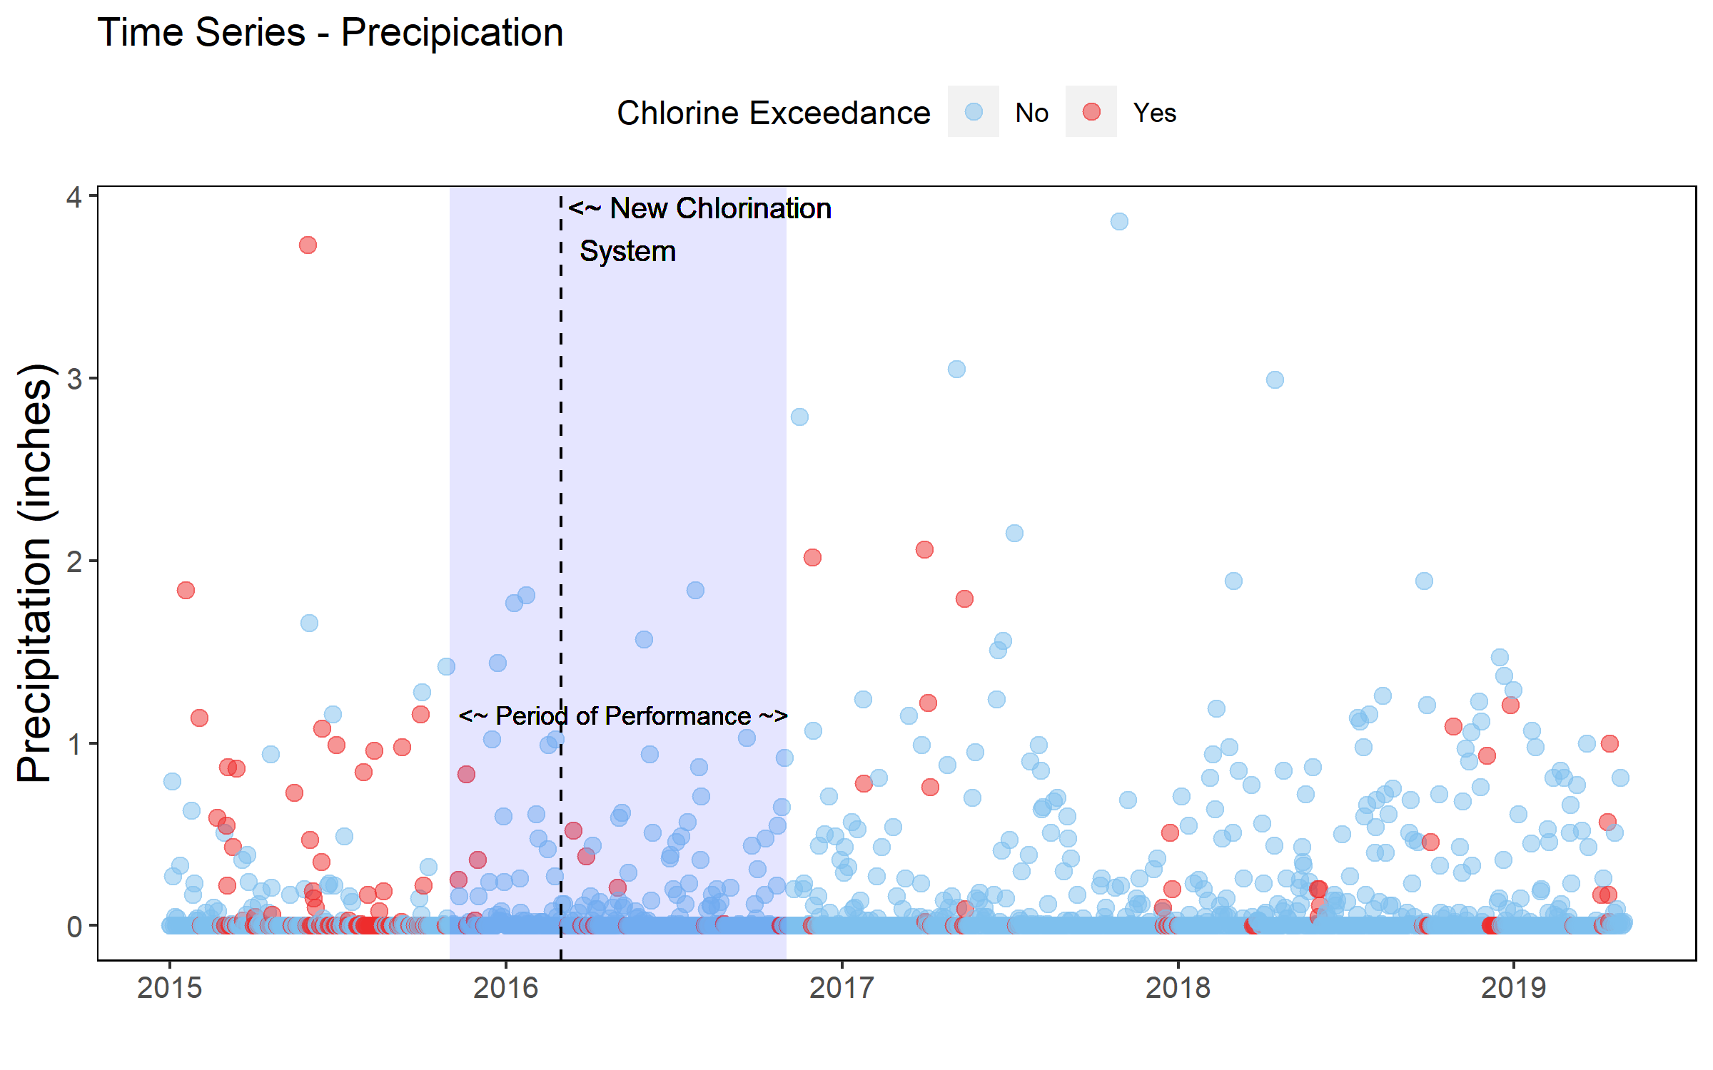

Figure 3-2 Precipitation and TRC

More detailed view of the process control sheets and PLC data were helpful in identifying the reasons for the elevated TRC levels during precipitation events. Data collected during two of the events is illustrated by **Figure 3-3**.

Both panels include the assigned mixer sodium hypochlorite dose (gray line), influent TRC as measured by the Hach analyzer (purple circle) and Prominent analyzer (brown circle), effluent TRC measured by the Hach (pink triangle) and Prominent (turquoise triangles) analyzers and the reported hourly TRC (burgundy line). Solids flux is also presented as orange triangles (only shown for the 12/20/2018 event in the lower panel).

Figure 3-3 Reported Influent and Effluent TRC Concentrations during October and December 2018 Storm Event

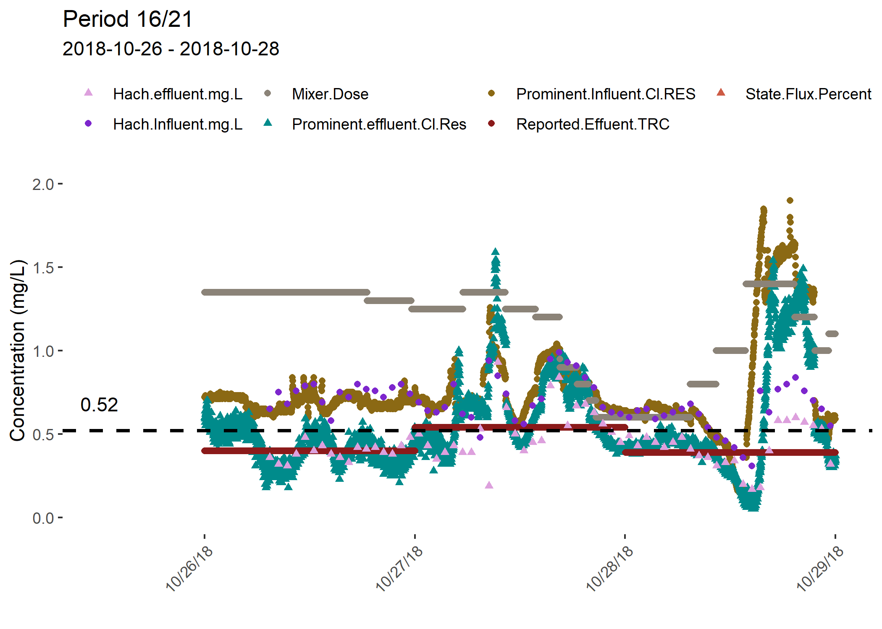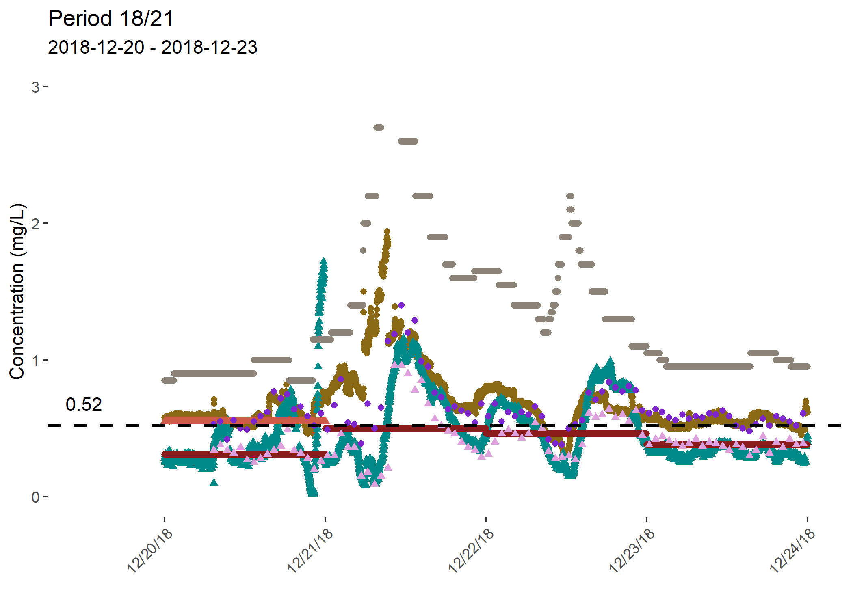

Review of the operator notes during the precipitation events revealed that during some precipitation events, the chlorine dose was proactively increased to address anticipated impacts from the wet weather. During the TRC exceedance beginning November 24, 2018, the effluent target was set at 0.50 mg/L to 0.60 mg/L to achieve disinfection.

These exceedances are attributed to storm flows on November 24 and 26, 2018, which washed out solids and resulted in low aeration solids concentrations. As a result of the heavy wet weather flows on December 1 and 2, 2018, the plant was inundated with grease and oil causing a bloom of M. Parvicella (a grease and oil filament). Between December 1 and 2, 2018, the sewage temperature dropped from 16°C to 12°C which further shocked the biology causing poor settleability. Finally, Final Settling Tank No. 3 was taken out of service for flight maintenance from November 27 to December 12, 2018, thereby reducing the surface overflow rate and detention time in the final settling tanks. The sudden temperature change, heavy influx of M. Parvicella, and decreased final settling time caused solids to remain in suspension and inhibited the increase of solids inventory. A high dose of sodium hypochlorite was sent to RAS and wasting was adjusted to increase solids inventory**.**

3.3 Process Control Challenges

Control of the chlorination process was identified as another potential factor during the observed elevated TRC intervals. The process control challenges were also observed during some of the precipitation events with high effluent TRC. For example, during the precipitation event highlighted in **Figure 3-3**, the process control sheets also reported that heavy solids were observed and the effluent TRC probe would not hold calibration.

The Port Richmond disinfection system was upgraded in 2016 and has been working well according to the Operating staff with the following exceptions:

* Prominent probes are not calibrated and are cleaned monthly. Because they cannot be used as part of the automated system, the ability to respond quickly to changing conditions is reduced.
* A hydraulic bottleneck downstream of the parshall flume results in surcharging of the flume during high flow events. As a result, the automatic dose pacing control currently uses the plant influent flow to calculate the hypochlorite feed rate, which can result in underfeeding/overfeeding due to the lag time between changes in influent and effluent flow. DEP is in the process of modifying the controls to provide more accurate effluent flow monitoring even during surcharged conditions.
* The CCTs have reportedly not been cleaned since 2015 – 2016 when the new chlorination system was being installed. This can impact the available volume for disinfection reducing actual contact time and can also result in the resuspension of solids during high flow events.
* The high range pumps were not turning on fully during wet weather. DEP was looking to trouble-shoot this issue with the manufacturer during a significant rain event

Use of the emergency drip was noted during seven of the 20 TRC exceedance intervals evaluated. A higher diffuser dose was reported during three of the 20 TRC exceedance intervals, because the mixer was reportedly not achieving the effluent target dose.

Because the Prominent probes have been observed to drift, and they are not maintained on daily basis, the plant could not rely on the automated system to control the chlorination process. The chlorine measurements reported by the Hach benchtop DPD analysis were compared to the chlorine measurements reported by the Prominent analyzers to assess reliability and differences. The data was filtered based on an outlier statistical approach of removing data with z-scores (standard score defining how many standard deviations a value is from the mean of the distribution) outside of the boundary between -3 and 3. This assumes data follows a gaussian distribution and maintains 99.7% of the dataset.

**Figure 3-4** shows the relationship between the measurements from the two instruments with and without outliers included. The regression coefficients show that there is a strong relationship between the Hach analyzers and the Prominent analyzers with an R2 of 0.69. The relationship was stronger on influent recorded data than effluent recorded data likely due to the tendency of the effluent Prominent probe to drift towards 0 mg/L over time. The slope of the line (without outliers) suggests that the Hach probe tends to measure chlorine at slightly greater concentrations which may be attributed to the Prominent probe’s drifting characteristics. The regression summary is provided in **Table 3-1** and all regression coefficients were statistically significant (p-value < 0.05).

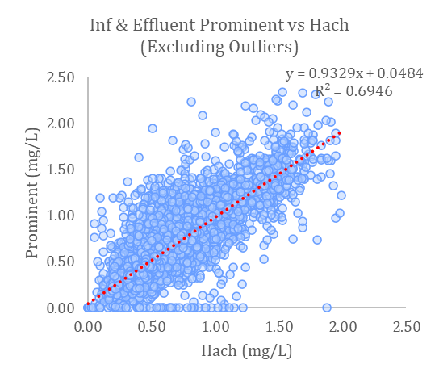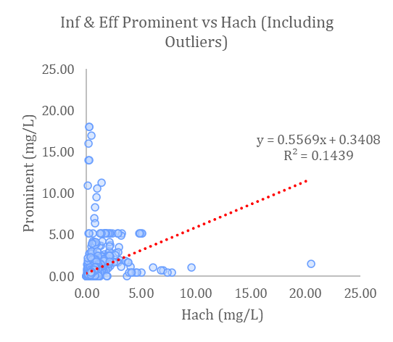

Figure 3-4 Comparison of Hach and Prominent Chlorine Measurements

Table 3-1 Comparison of Hach and Prominent Chlorine Measurements

|  |  |  |  |  |
| --- | --- | --- | --- | --- |
| Data Summarized | With Outliers | | Without Outliers | |
| Coefficient of Determination (R2) | Slope | Coefficient of Determination (R2) | Slope |
| Influent and Effluent Probe Data | 0.14 | 0.56 | 0.69 | 0.93 |
| Effluent Probe Data Only | 0.04 | 0.49 | 0.47 | 0.83 |
| Influent Probe Data Only | 0.02 | 0.48 | 0.91 | 0.62 |

3.4 Discharge from Visy Paper

Port Richmond noted potential filamentous growth at their facility on several occasions when also receiving Visy Paper discharges, and this may be by a product of process upsets in secondary treatment process upsets. Several causative factors may be insufficient dissolved oxygen, temperature, pH, and food balance (carbon:nitrogen:phosphorus), and carbon source. **Figure 3-5** shows that Visy Paper comprises a significant percentage of the cBOD entering Port Richmond where the majority of the time the ratio is between 37-57 percent. With such a large portion of the cBOD coming from Visy Paper, the environment in Port Richmond’s waste activated sludge process can speciate bacteria that are preferential to that substrate. It is not known whether the Pratt Paper discharge is consistently released over 24 hours, or if it is released to the Port Richmond plant in batches. If the Pratt Paper discharge is released to Port Richmond in batches, or over a single shift, the impact of the high strength waste will be even more significant during that duration. When the plant received wastewater of inconsistent strength, bacteria will be challenged to acclimate to constant change and this can result in filamentous growth and bulking sludge.

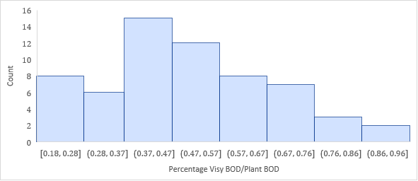

Figure 3-5 Percentage of Port Richmond BOD Load from Visy Paper

3.5 Variation in Chlorine Demand

The potential for variable wastewater quality to impact chlorine demand and effluent residual was evaluated by implementation of the June/July 2019 field sampling program described in Section 2.5. Wastewater quality throughout the process train was evaluated based upon samples collected:

* At the influent;
* After primary settling/upstream of aeration;
* After settling in the final tanks;
* From the CCT effluent.

The sampling results showed that levels of pathogen indicator organisms measured in the raw plant influent wastewater samples were generally consistent, at high 106 MPN/100 mL for fecal coliform and 106 MPN/100 mL (except for one day when the influent concentration was an order of magnitude lower) for enterococcus. Concentrations leaving the primary settling tanks/entering secondary treatment were generally lower for enterococcus at 105 MPN/100 mL and varied between 105 and 107 for fecal coliform. The data suggested that variability in secondary treatment may have an impact on disinfection as the concentrations of fecal coliform exiting the final clarifiers varied by three orders of magnitude (103 to 106) and concentrations of enterococcus varied by two orders of magnitude (103 to 105).

The chlorine demand testing conducted on two days of sampling also indicated the variability of CCT influent wastewater quality; the chlorine dose required to achieve an effluent target of 0.4 mg/L was 1.25 mg/L on the first day of testing (0.91 mg/L demand) and approximately 2.0 mg/L on the second day of chlorine demand testing (1.7 mg/L demand with a resulting 0.3 mg/L residual).

3.6 Solids Flux

A clarifier state point analysis (SPA) was performed for Port Richmond based on the provided DMR data in order to assess whether the final settling tanks were stressed based on solids loading and settling capacity. The state is a graphical approach derived from solids flux theory. It takes into consideration mixed liquor concentrations, settling characteristics, available surface area for compaction, and recycled flow rates. **Figure 3-6** provides an explanation of the elements considered in a state point analysis. A clarifier is considered overloaded when the state point (intersection of overflow and underflow rate operating line) is above the settling flux curve, or when the underflow rate goes above the settling flux curve.

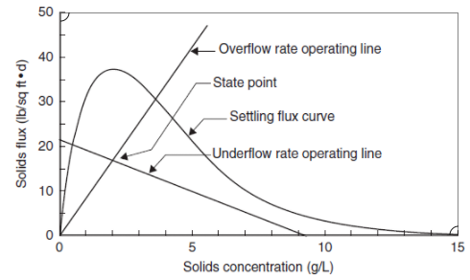

Figure 3-6 State Point Characteristic Curve

The theoretical settling flux capacity on each day was calculated for each day at Port Richmond with a 1.3 safety factor. **Figure 3-7** is a timeseries representing the ratio of the state point solids flux to the actual clarifier settling flux and clarifier overloading would occur on days this value is >1. The dots represent the ratio of state point solids flux and clarifier settling flux. On days where chlorine exceedances occurred the dots are highlighted in red to identify potential coincident events. The analysis showed that the facility generally does not have issues with clarifier capacity or solids removal. Two events where the settling flux was overloaded or critically loaded occurred prior to the chlorination system upgrade and both events exhibited chlorine exceedances on those days. Two additional observations of critically or overloaded clarifiers occurred after the chlorination upgrade, but these events did not have concurrently occurring TRC exceedances.

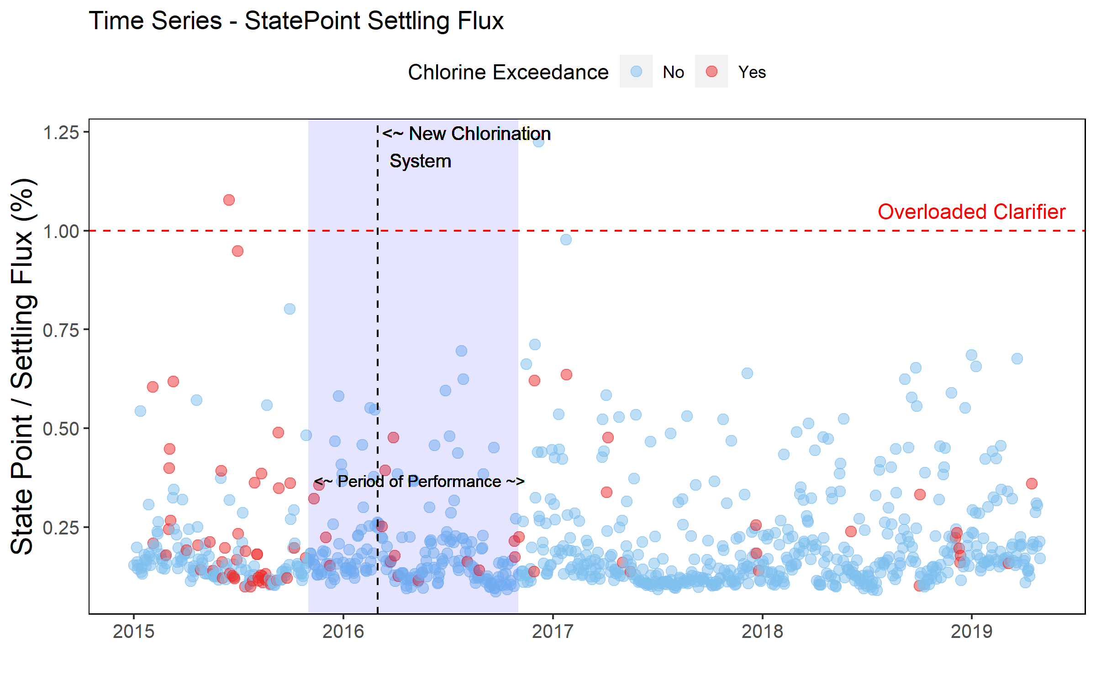

Figure 3-7 State Point / Settling Flux Over Time

3.7 RAS Chlorination

Return Activated Sludge (RAS) chlorination occurred during ten of the 20 periods of elevated TRC concentrations that were evaluated. It is not clear whether this results in higher than anticipated residual chlorine residual.

Review of the AT sheets for June and July 2020 suggested that the plant reduces the disinfection target during the days that RAS chlorination is occurring.

During the initial days of the sampling program, DEP maintained a residual target of 0.25 mg/L which is relatively low in comparison to the residual target 0f 0.4 mg/L identified in Port Richmond’s historical daily monitoring reports. The residual target was increased to 0.35 mg/L on July 7th (the 4th sampling day) and then to 1 mg/L on July 10th (the 7th sampling day). This residual target increase is likely due to the relatively high effluent bacteria concentrations observed during the prior days. The residual target was reduced to 0.45 mg/L on July 13th (8th sampling day) where it remained for the duration of the sampling program.

Another chlorine application point at Port Richmond is within the return activated sludge (RAS). RAS is chlorinated to mitigate bulking sludge and filamentous organism growth that may be caused by poor aeration control. DEP has provided information on RAS chlorination and during the first four sampling days, the RAS chlorine dose was relatively high at 8.8 mg/L. This may explain why the TRC target was set lower than usual at 0.25 mg/L. The RAS chlorination dosage was reduced to 6.3 mg/L on the 4th day of sampling (and the chlorine residual target was increased to 0.35 mg/L) and then set to 0 mg/L on the 8th sampling day for the duration of the program.

3.8 Sodium Hypochlorite Use

The potential that variation in the strength of the sodium hypochlorite delivered to the CCTs could be contributing to effluent TRC variation was also considered by reviewing sodium hypochlorite use at the plant and comparison of deliveries to dates of elevated TRC. Port Richmond did receive sodium hypochlorite deliveries during eight of the 20 exceedance events, and switching hypo tanks was noted during 11 of the 20 events. Port Richmond has three 10,000 gallon bulk storage tanks and one 1,200 gallon emergency drip tank that will flow by gravity if there is a disruption to the chlorination system such as a power outage. On average, 5,000 gallon sodium hypochlorite (NaOCl) deliveries are made to the facility 3 to4 times per month. Deliveries occurred every 8 days on average, but there have been up to 49 days between deliveries.

The breakdown of hypochlorite deliveries from 2015 to 2019 are provided in **Table 3-2**.

Table 3-2 Port Richmond Chlorine Deliveries

|  |  |  |
| --- | --- | --- |
| Year | Average Deliveries Per Month | Total Deliveries |
| 2015 | 3.67 | 44 |
| 2016 | 3.50 | 42 |
| 2017 | 3.42 | 41 |
| 2018 | 4.33 | 52 |
| 2019[1] | 2.00 | 24 |

[1] – 2019 data from January 1st to April 30th

The hypo solution received at the facility is a 15 percent hypochlorite solution. Although this is the trade percentage, true available chlorine by % weight of this solution is approximately 12.4 percent and this is the most common strength used for disinfection applications with NaOCl. Chlorine half-life is estimated in **Figure 3-8** for three different trade percentages at different temperatures. Interpolating between 10% and 20% at a room temperature of 70 F, the half-life of the chlorine at Port Richmond is expected to be between 100 – 200 days. This can potentially result in increased use chlorine to meet the same dosing requirements. The DMRs indicate that tank 1 is the fill tank of choice and the three tanks are hydraulically connected with an equalization line.

The June and July 2020 AT sheets show that an average of 12,000 to 15,000 gallons of sodium hypochlorite was stored on-site during those months. During June 2020, 20,154 gallons were delivered to the Plant, 23,781 gallons were consumed (only 8,781 of this use was for disinfection) resulting in a reduction of 3,627 stored gallons over the month. During July 2020, 24,280 gallons of hypochlorite were delivered, 21,172 gallons were consumed (14,047 for disinfection), resulting in an increase of 3,648 gallons in hypochlorite storage.

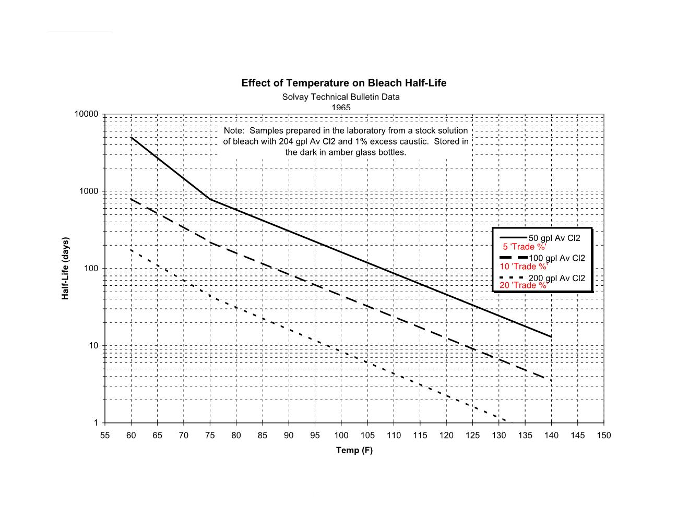

Figure 3-8 Chlorine Half-life

3.9 Data Evaluation Approach

In an effort to identify any measured wastewater quality or process parameters that may be impacting disinfection at Port Richmond, predictive statistical models were used to assess the relative importance of the different factors affecting chlorine exceedance amongst all of the potential factors identified. This involved

* Spearman correlations
* Support Vector Machine – Decision tree
* Logistic Regression
* Random Forest

Only data collected after the chlorination upgrade (3/1/2016) was used for the statistical analyses. Of the four methods, three were used as classification models to predict if Port Richmond would experience chlorine exceedances based on the data collected. The classifications shown in **Table 3-3.**

Table 3-3 Exceedance Event Proportions

|  |  |  |  |
| --- | --- | --- | --- |
| Metric | Classification | | Total |
| Exceedance Event | Non-Exceedance |
| Count | 66 | 1090 | 1,156 |
| Proportion | 6% | 94% | 100% |

When modeling data with a class imbalance of this nature (6% chlorine target exceeded:94% chlorine target compliance), models will typically provide results that accurately predict the majority class (non-exceedance events) but will fail to correctly classify exceedance events. In preparation for applying the classification models to the datasets, under sampling of the majority class was performed so that the models would not be skewed towards predicting non-exceedances, which resulted in sample sets with equivalent number of exceedances and non-exceedances. Cross-validation was performed on each model’s datasets with bootstrap resampling to provide a measure of confidence on model accuracy. Of the three classification models, the random forest performed the best as shown in **Table 3-4.**

Table 3-4 Data Model Accuracies

|  |  |  |
| --- | --- | --- |
| Model | Accuracy | 95% Confidence Interval |
| Baseline (No Model) | 50% | 44-56% |
| SVM Decision Tree | 62% | 53-70% |
| Random Forest | 67% | 60-73% |
| Logistic Regression | 66% | 59-72% |

The Receiver Operating Characteristics (ROC) curve shown in **Figure 3-9** depicts the accuracy of each statistical model in comparison to the baseline of simply guessing if there will be a TRC exceedance event. All three statistical models performed better than guessing indicating that the underlying causes may be explained by the parameters considered at least part of the time. Sensitivity is a measure of the model’s accuracy towards predicting true positives, and specificity measures model accuracy of predicting true negatives. The models were split into 75/25 (training/testing) datasets.

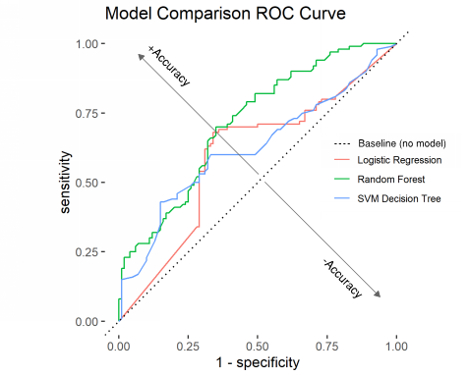

Figure 3-9 Model Receiver Operator Characteristic Curve Comparison3.9.1 Statistical Evaluations

3.9.1.1 SVM Decision Tree

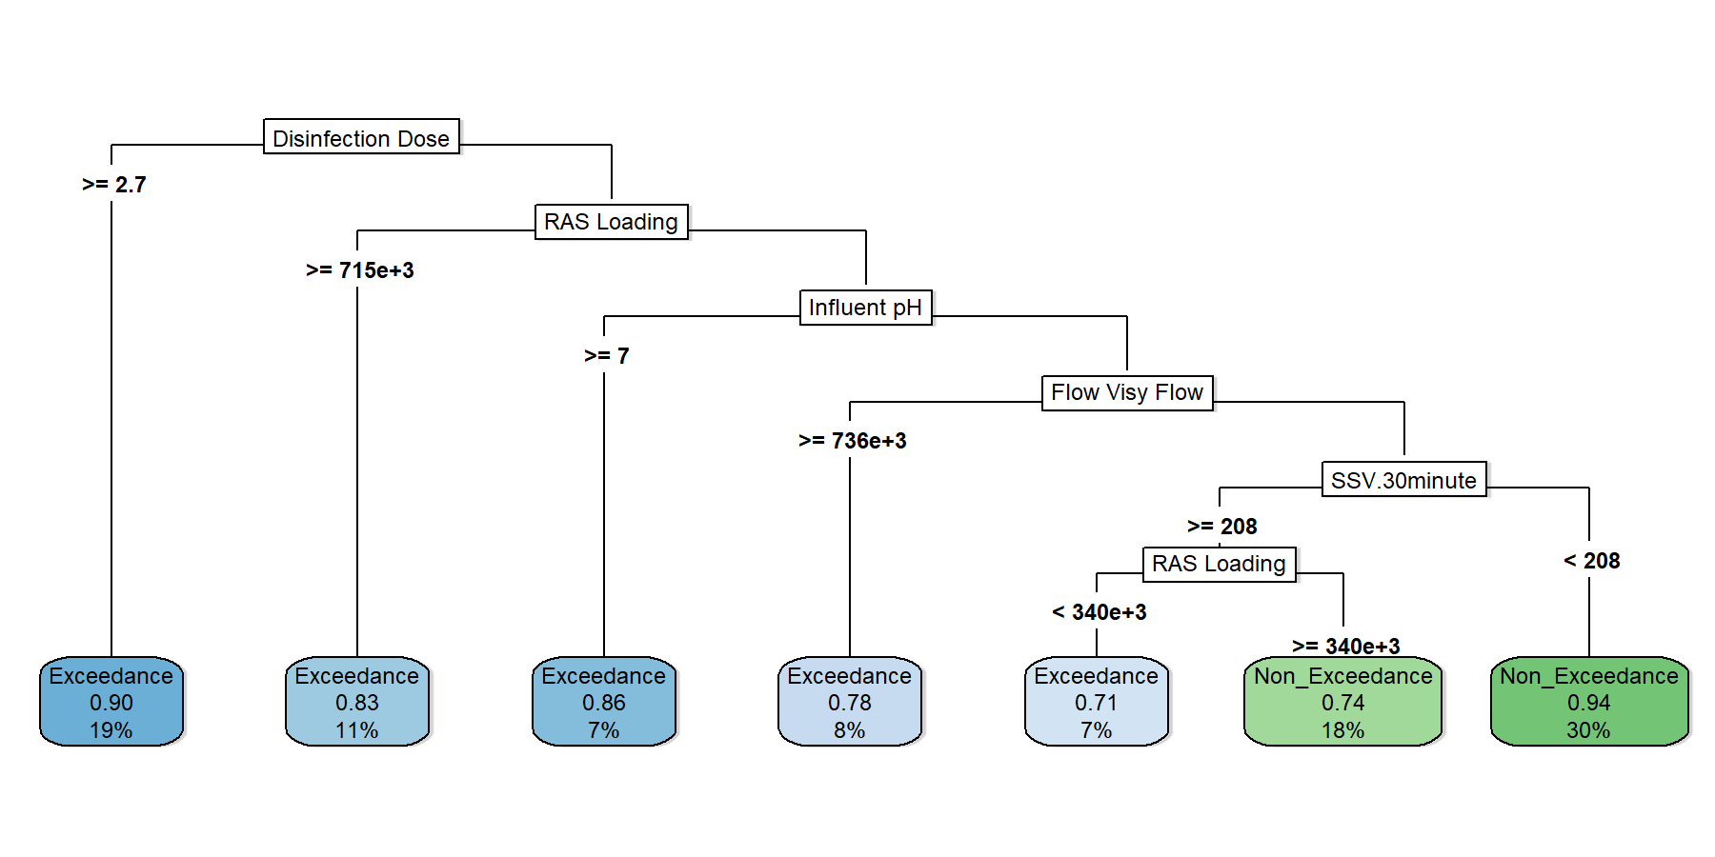Decision trees are a supervised machine learning method used for classification and regression problems. This method operates by segmentation and aims to reduce the entropy of a dataset by continually splitting the data in a tree like structure by the most informative variables. An *example* decision tree from a subset of Port Richmond data is shown below where the root node (top most node) represents the best delimiter of the data and splitting continues down the tree until getting to the leaf nodes where the final classification is shown (exceedance, non-exceedance) the probability of that classification, and the percentage of the sampled data that remains in that leaf node.

Figure 3- 10 Example Decision Tree on Subset of Port Richmond Data

[1] – Leaf node (bottom of tree) display predicted classification (exceedance/non-exceedance), probability that predicted classification is correct, and percentage of data from dataset used in in classification

The specifications for the decision tree can be found in **Table 3-5**. After running the model on cross-validation data under several random samples, the variable importance for the decision tree model was extracted and only the top 20 parameters are shown in **Figure 3-10.** The metric used to measure variable importance is a gini impurity reduction index where gini impurity is a measurement of how likely a variable will incorrectly classify a random sample. Disinfection dose, plant BOD loading, effluent TSS and flow were major predictors of chlorine exceedances and overall model accuracy in terms of correctly identifying whether a TRC sample would exceed the target of 0.52 mg/L measured 62% ± 8%.

Table 3-5 Decision Tree Model Configuration

|  |  |
| --- | --- |
| **SVM Decision Tree Specifications** | |
| Type | Classification |
| Prediction | Chlorine Exceedance |
| Min observations required to split node | 20 |
| Min observations in terminal node | 7 |
| Cross-validation type | Monte-Carlo |
| Cross-validation computes | 25 |
| Max tree depth | 30 |

3.9.1.2 Logistic Regression

Logistic regression in lieu of linear regression was used since our metric is a categorical classification (exceedance/non-exceedance event). This model measures the relationship between the dichotomized (binary classification) dependent variable (chlorine exceedance) by one or more predictor independent variables (e.g., wastewater quality or process measures) through a logistic function. An S-shaped sigmoid curve is fit to our observations determined by the equation:

$$Probablilty=\frac{1}{1+e^{-x1}}+\frac{1}{1+e^{-x2}}….+\frac{1}{1+e^{-xn}}$$

Where the probability determines the classification of the dependent variable (e.g., TRC > 0.52 mg/L) and where *x* represents the weighted sum of independent variable(s) used to make a prediction. An *example* logistic regression function is shown in **Figure 3-11** using just one predictor variable, disinfection dose where probabilities > 50% will predict TRC exceedances. The final model used all variables described in **Section 2.1** and creates a classification function where variable importance is shown side by side with the SVM decision tree and random forest in **Figure 3-12**. Variables/factors that affected whether or not TRC exceeded 0.52 mg/L include BOD, solids, and bacterial measures. This model maintained an accuracy measure of 66% ± 7%.

Table 3-6 Logistic Regression Model Configuration

|  |  |
| --- | --- |
| **logistic Regression** | |
| Type | Classification |
| Prediction | Chlorine Exceedance |
| Cross Validation Type | Monte-Carlo |
| cross-validation computes | 25 |

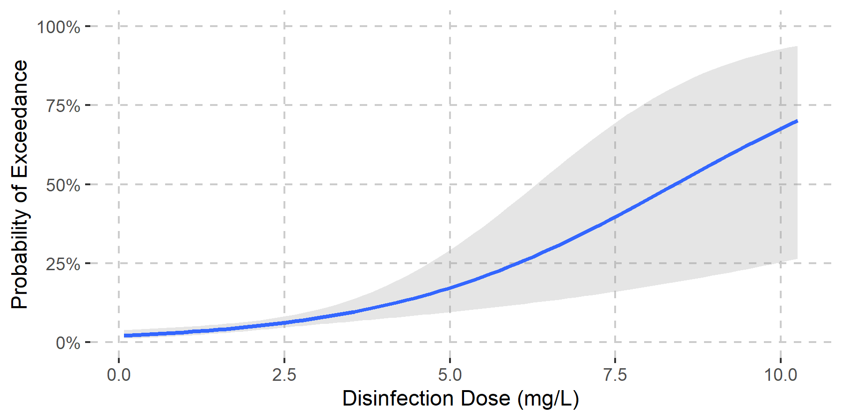

Figure 3-11 Sample Logistic Regression with Disinfection Dose as only Predictor Variable

3.9.1.3 Random Forest

A random forest is another supervised learning algorithm that combines the predictions of many smaller models to produce an aggregated prediction of whether or not TRC will exceed 0.52 mg/L. Specifically, a random forest is a collection of decision trees that each provide their own predictions, which are combined to produce a final prediction. Random forest models typically provide more accurate results than decision trees due to its ensemble structure and they are less susceptible to overfitting (predicting well on training data while predicting poorly on new data) Training data is defined as the subset of data used to develop the model and this is cross-validated with the remaining data that was used to train the models. At every node in every tree of a random forest, a limited number of parameters are selected at random and used to partition the data. Doing this over many trees allows these models to not be as heavily influenced by minor changes to the training datasets. Statistical conditions applied to the random forest for classifying chlorine exceedances are presented in **Table 3-7**.

Table 3- Random Forest Model Configuration

|  |  |
| --- | --- |
| Random Forest | |
| Type | Classification |
| Prediction | Chlorine Exceedance |
| Number of decision trees | 500 |
| Number of randomly selected parameters per node | 14 |
| Bootstrap sampling method | With replacement |
| Minimum observations in required terminal nodes | 7 |
| Cross-validation type | Monte-Carlo |
| Cross-validation computes | 25 |

The random forest was the most accurate of the models with a measure of 67% ±7%. **Figure 3-12** shows the top 20 variables deemed most important to exceedance events by each statistical model. Similar to the decision tree and logistic model, disinfection dose and plant BOD loading were strong drivers. Other notable factors include effluent TSS, Visy Paper loading, and RAS loading rates. Surprisingly, precipitation was not identified as a significant factor.

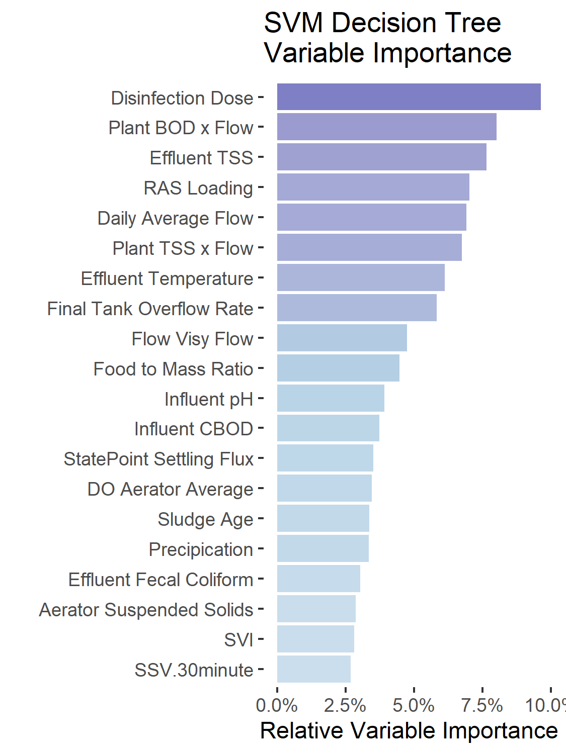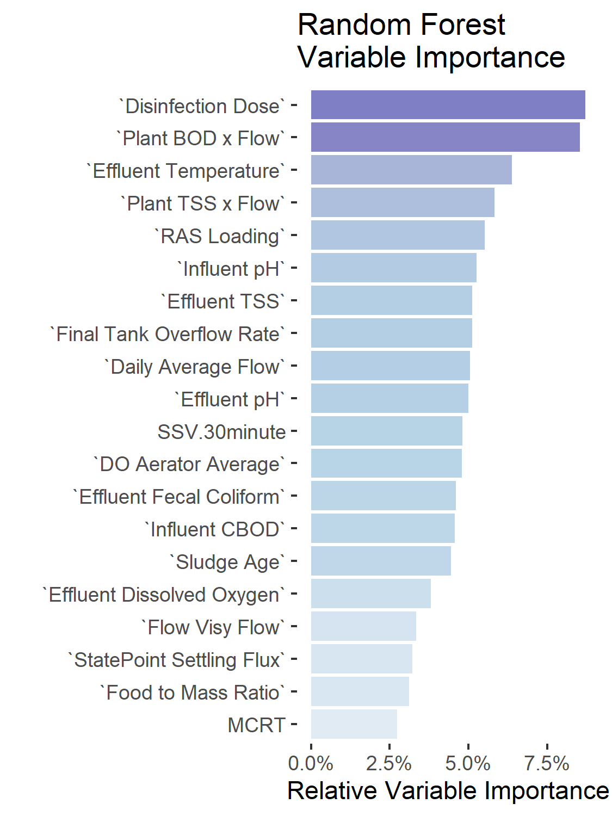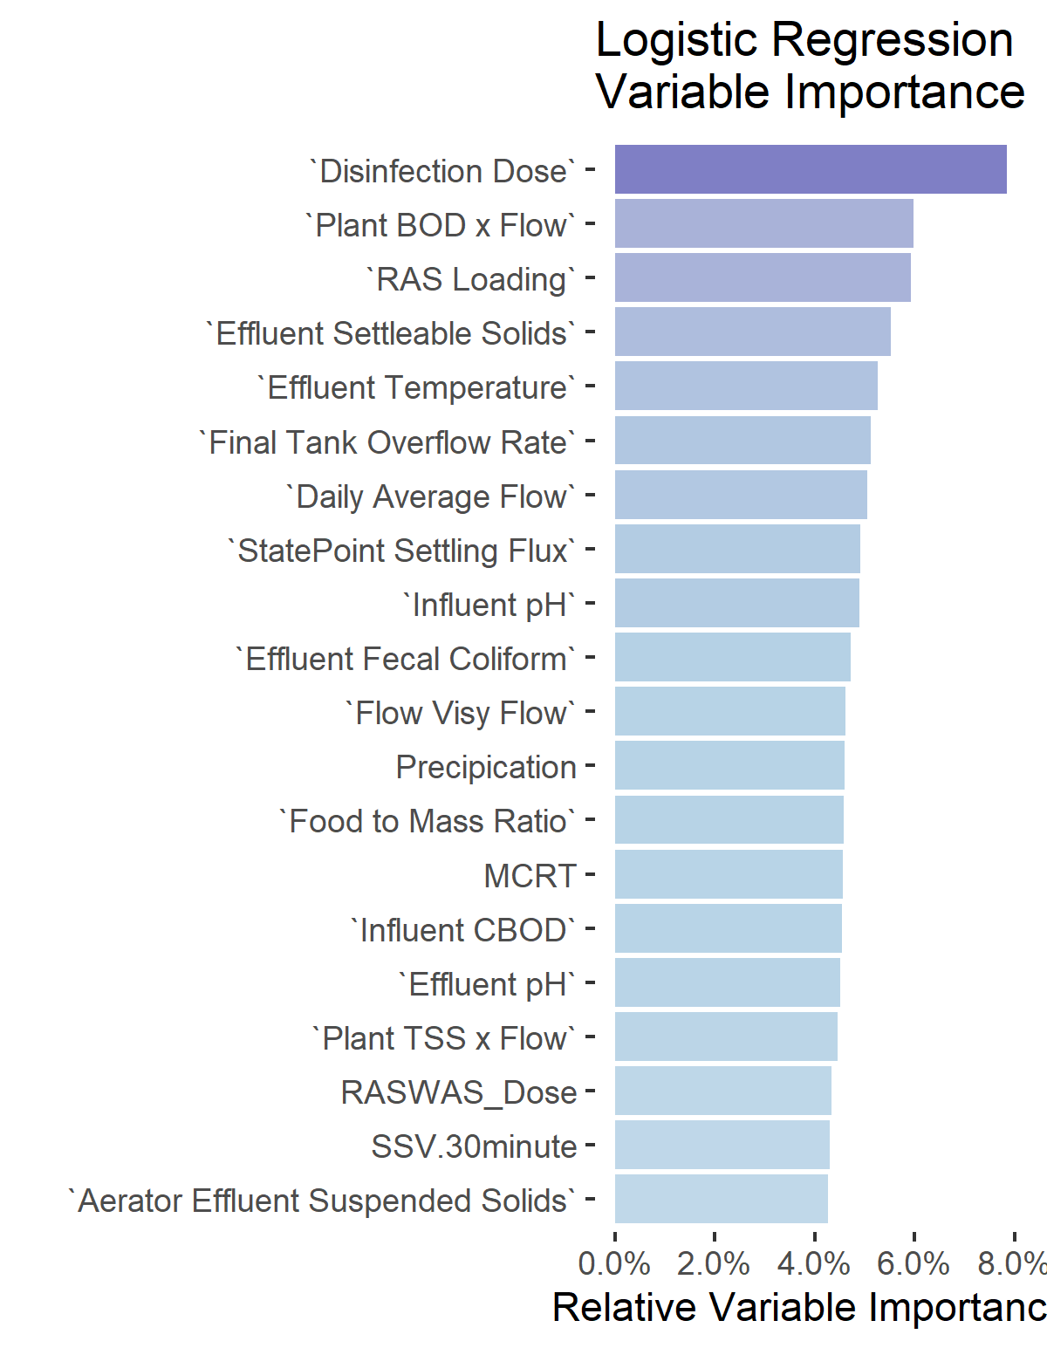

Figure 3-12 Factors Most Often Occurring When Effluent TRC Exceeded 0.52 mg/L

3.9.1.4 Regression

Due to the class imbalances, standard regression analyses were not used as there are insufficient observations of high chlorine concentrations in the effluent. Even so, spearman regression coefficients were computed throughout the entire dataset as a measure of monotonicity and most parameters returned R2 values less than 0.1. Values that returned higher than 0.1 were either directly related to chlorine such hypo pump flow, or had a p-value >0.05 indicating the regression coefficient is statistically insignificant likely due to lack of coincident samples between TRC concentration and the predictor variable.

**Figure 3-13** displays box plots showing the predicted variable (effluent TRC concentration) as a function of some of the variables deemed significant by the variable importance evaluations. Box and whisker plots are distribution plots where the box represents the interquartile range (25th to 75th percentile) of the observations, the whiskers represent 1.5x the interquartile range, and points outside of the whisker range are considered outliers.

**Figure 3-14** shows TRC concentrations as a function of binned chlorine dose. The data were binned (grouped) to better identify trends associated with chlorine residual concentrations that are not easily recognizable in standard regression and as expected, the spread of residual concentrations increases as chlorine doses increase. Similarly, when observing BOD loading rate to the facility, the likelihood of exceedance events increase as greater concentrations of chlorine residual in the effluent are observed in BOD loading rate bins of higher concentrations. Because Visy Paper comprises a significant portion of the facility’s BOD load, **Figure 3-15** is showing that as the Visy Paper flow increases, the median effluent TRC as well as the IQR of chlorine concentrations also increase. This may imply a potential contributing factor to activated sludge instability and resultant higher TRC concentrations.

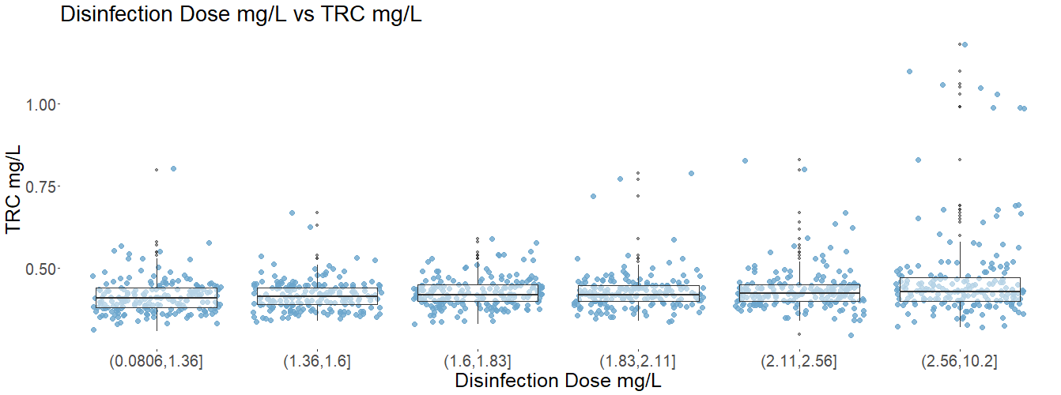

Figure 3-13 Effluent TRC concentrations by Binned Disinfection Dose (Bin intervals defined such that they contain an equivalent number of TRC observations)

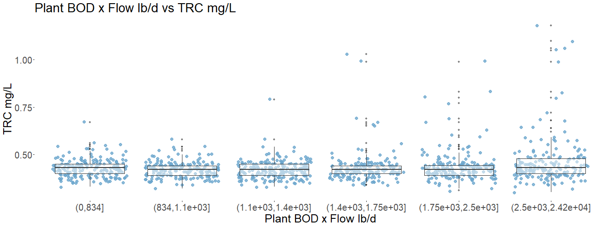

Figure 3-14 Effluent TRC concentrations by Binned influent BOD Loading Rate (Bin intervals defined such that they contain an equivalent number of TRC observations)

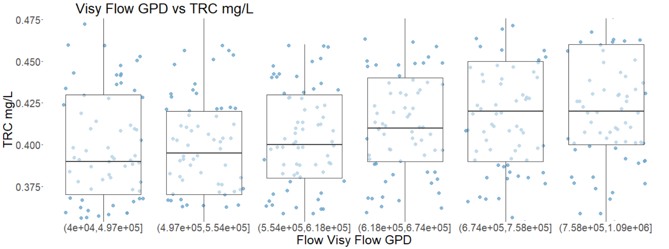

Figure 3-15 – Effluent TRC concentrations by Binned Visy Paper Flow Rate (Bin intervals defined such that they contain an equivalent number of TRC observations) [*]Plot is zoomed in and does not show all TRC observations

**Figure 3-16** shows chlorine concentrations as a function of binned effluent fecal coliform concentrations. This plot provides insight into when bacterial concentrations start to increase the probability of an exceedance event which becomes increasingly apparent when 7-day geomeans approach 200 cfu/100mL (notably, the permit limit is a 30-day geomean of 200 cfu/100mL) indicating operators likely prioritize meeting bacterial permit limits above achieving the proposed TRC limit.

Effluent TSS bins are shown in **Figure 3-17** to illustrate the increasing probability of higher chlorine concentrations associated with high effluent TSS. TSS is another factor associated with the activated sludge process and can be affected by BOD and process performance. Although higher TSS may exert more chlorine demand and result in less residual, several log sheets indicated that operators tend to increase chlorine dose when solids are notably higher in the influent to the chlorine contact tanks to ensure an adequate bacterial kill.

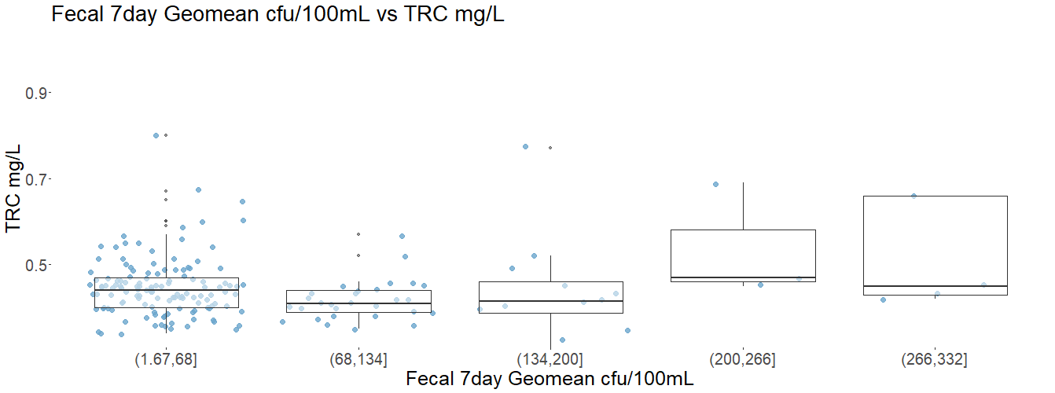

Figure 3-16 TRC concentrations by Binned Fecal Coliform 7-day Geomean (Bin intervals defined such they are the same length independent of number of observations) [*]Plot is zoomed in and does not show all TRC observations

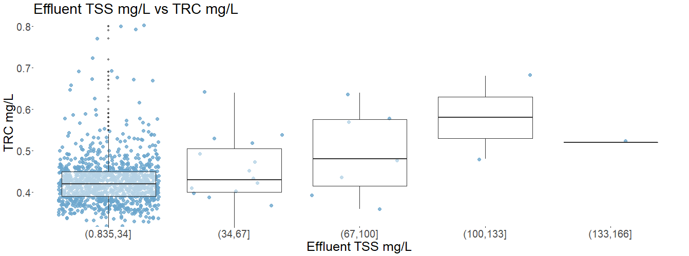

Figure 3-17 TRC concentrations by Binned Effluent Suspended Solids (Bin intervals defined such they are the same length independent of number of observations) [*]Plot is zoomed in and does not show all TRC observations

3.9.1.5 Results of Statistical Evaluations

Results of the statistical evaluation provided insight into factors that were weighted heavily when predicting if the facility will have experience a chlorine exceedance event. The entropy-reduction based approaches (Decision Tree and Random Forest) as well as the binary regression approach (Logistic Regression) all shared the similar feature importance metrics where disinfection dose, BOD loading, RAS loading, effluent TSS, and Visy paper flows were indicative of exceedance risks. Metrics pertaining to secondary treatment such as solids settleability, F/M, and sludge age we’re also common. Because feature importance is spread out without heavily weighted major predictors, the implication is that variability amongst the features listed have relatively comparable probabilistic impacts on disinfection efficacy.

Section   
Conclusions and Recommendations

4.1 Conclusions

It is clear from recent plant operating data, that the Port Richmond WWTP can routinely achieve its required fecal coliform inactivation while also operating with a low effluent TRC, well below the target of 0.52 mg/L. Data from the last TRC and Fecal Performance Update showed that from November 2019 through October 2020, the monthly average effluent TRC ranged from 0.23 to 0.32 mg/L. However, the daily maximum TRC for this same period ranged from 0.30 to 0.96 mg/L, exceeding the target of 0.52 mg/L for 2 out of 12 months. The issue becomes one of consistency, and whether the plant can consistently operate with a daily maximum effluent TRC below the 0.52 mg/L target while also meeting fecal inactivation. This appears to be further challenging if NYSDEC were to adopt the enterococcus STV of 30 cfu/100 mL as an effluent limit. During the summer 2020 sampling event, the mean effluent TRC was 0.43 mg/L, while the geometric mean for enterococcus and fecal coliform were 36 and 114 cfu/100 mL. Showing that the results were well within the 30-day fecal limit, but exceeding the enterococcus STV.

No single causative factor could be identified as resulting in the exceedances of the TRC target. Rather there appear to be multiple, complex factors that are contributing to the variability in the control of the effluent TRC. The major factors affecting disinfection performance and the resulting chlorine dose and residual include:

* Effluent quality variability (chemical composition and bacterial counts),
* Impact of Pratt/Visy Paper discharge on the plant secondary treatment performance,
* Variable chlorine demand and the use of manual chlorine dose adjustment strategy rather than automated control with residual feedback,
* Impact of bulking sludge and filamentous growth events on the process operations including effluent quality and chlorine dose,

A somewhat brute-force statistical analysis of this historical data since the completion of the chlorination upgrade in 2016 identified common factors most associated with TRC exceedances:

* Disinfection dose
* Plant BOD loading
* Effluent TSS
* RAS loading
* Daily flow
* Plant TSS loading
* Effluent temperature

Effluent variability is viewed as a major factor impacting the overall disinfection performance and the ability to tightly control the TRC residual below the 0.52 mg/L target while also maintaining bacterial inactivation. It is notable that during the summer 2020 sampling event, the concentration of both fecal coliform and enterococcus in the CCT influent varied by over 2-logs. Because the effluent bacteria concentration is a function of the influent concentration and the CCT log reduction for a given chlorine dose and contact time, a 2-log increase in the influent concentration will result in a proportional increase in the effluent concentration. Most often, this will appear as noise in the effluent bacteria monitoring, forcing the operator to increase the chlorine dose in order to decrease the daily bacteria results, or when there is a trend that might exceed 7-day or 30-day reporting limits. Effluent variability can also result in significant variability in chlorine demand, which can be difficult to compensate for without using automatic control and residual feedback. With the current strategy of manual dose adjustment based on hourly grab sample analysis, the dose adjustment will always be lagging the process.

The presence of bulking sludge and filamentous growth is a recurring problem at the Port Richmond WWTP. This appears to be affecting the disinfection system performance both based on operation and on disinfection log-reduction. The plant operators over the summer sampling event adjusted the disinfection dose when they were chlorinating RAS, making more difficult to consistently meet a low residual limit. Additionally, it is possible that at times during these events that the solids composition of the effluent TSS is different resulting in a larger particle size distribution. Larger particles in the effluent can reduce disinfection effectiveness by partially shielding bacteria within the solids particle and requiring a higher chlorine dosage to achieve the same log reduction. On average, TSS removal is quite good with mean effluent TSS of 8.3 mg/L since 2016. However, poor settling sludge has often been observed, including recently when visible paper particles were reported in SVI column tests. It is also notable that PSD analysis performed during the summer 2020 sampling event showed a significant shift to larger particles as compared to PSD analysis performed in 2005 as part of the initial TRC Program study.

The discharge from Visy Paper is likely contributing to and exacerbating the bulking sludge and filamentous growth occurrences at the plant. This is also compounded by the condition of the aeration system (i.e., dead spots, broken air headers/diffusers, lack of oxygen/DO control) and with control of flow splitting. The BOD loading from Visy Paper represents upwards of 50% or more of the total plant BOD loading. It is unclear whether this discharge is relatively constant or more of a batch discharge and whether the BOD is mostly in the soluble form or particulate. If it is mostly soluble as would be expected from this type of discharge and on a shift or batch basis, this further impacts the secondary process by promoting the conditions for bulking sludge and filamentous growth.

Precipitation and settling flux capacity did not correlate well with TRC exceedances. Certain large precipitation events, primarily those resulting in some solids washout, did result in process upsets which led to TRC exceedances. But most precipitation events did not seem to impact TRC compliance. Regarding settling flux, the final settling tanks are typically operated well below their theoretical settling flux. Over the period evaluated, the state point only approached the theoretical settling flux on 3 days, 2 of which corresponded with TRC exceedances. Many other times the state point was elevated without observed TRC exceedances, and conversely many other times the state point was low while there were TRC exceedances. Which indicated that the two were poorly correlated.



4.2 Recommendations

The Port Richmond WWTP is performing quite well in meeting a low TRC target while also achieving bacteria effluent limits, given some of the challenges at the plant. The following recommendations are made to improve the overall disinfection performance and provide a more consistent effluent TRC. Given how close the plant has maintained TRC and disinfection performance over the last year, it seems likely that with some or all of these recommendations that they could more reliably meet a TRC target of 0.52 mg/L.

* Repair/upgrade the secondary treatment process, including:
  + Aeration system improvements
  + Flow distribution improvements including replacement of stuck gates and valves
* Address the Visy/Pratt Paper discharge to reduce BOD loading on the WWTP
* Improvements to the chlorination control system, including:
  + Address the effluent flume flow monitoring and surcharge issue so that it can be used for dose pacing,
  + Perform regular maintenance and calibration of the Prominent TRC probes,
  + Operate the chlorination system in automatic mode with dose pacing and residual feedback.

Appendix   
Insert Appendix Title Here

This page intentionally left blank.

Appendix   
Insert Appendix Title Here

This page intentionally left blank.